Neural Mechanisms of
Goal-Directed Behavior
and Learning
Edited by
RICHARD F. THOMPSON
Department of Psychobiology
University of California, Irvine
Irvine, California
LESLIE H. HICKS
Department of Psychology
Howard University
Washington, D.C.
V. B. SHVYRKOV
Institute of Psychology
Academy of Sciences of the USSR
Moscow, USSR



New York

ACADEMIC PRESS 1980
A Subsidiary of Harcourt Brace Jovanovich, Publishers
London Toronto Sydney San Francisco

YU. I. ALEKSANDROV YU. V. GRINCHENKO

Hierarchical Organization of
Physiological Subsystems in
Elementary Food Acquisition Behavior
12
The problem of physiological mechanisms of behavior is essentially a problem of organizing the physiological functions of many elements into a singly integrated functional system of the behavioral act. A functional system of any behavioral act constitutes the integration of many subsystems, and at the same time is part of a system on a higher level. An analysis of the hierarchical organization of systems (Anokhin, 1973) is therefore of fundamental importance to a study of behavioral mechanisms. Our task was to study experimentally the hierarchical organization of subsystems of separate movements, muscle activity, and neuron firing in actuating mechanisms of the elementary behavioral act of taking food that is common to food acquisition behavior of variable complexity. The functioning of motor cortex neurons, spinal motor neurons, and the muscle proprioceptive apparatus is associated w⁷ith the realization of the actuating mechanisms of behavior. Therefore, a solution to the aforementioned problem necessitates a study of the correlation between the neuron activity of the so-called motor system and the subsystem hierarchy of the actuating mechanisms in the functional system of the food-taking behavioral act. Such a study requires a preliminary explanation of the relationship between the subsystems of individual movements that are identifiable by the results they are supposed to achieve and the relationship between individual movements and muscle activity.

NEURAL MECHANISMS OF
GOAL-DIRECtED BEHAVIOR AND LEARNING
177
Copyright © 1980 by Academic Press, Inc.
All rights of reproduction in any form reserved.
ISBN: 0-12-688980-5
178 Yu. I. Aleksandrov, Yu. V. Grinchenko
Method
Large (10 X 10 X 10 mm) and small (2-3 mm thick flakes) pieces of carrot pinned to the stem of the feeder device (Figure 12.1 [a, 1]) were presented to rabbits loosely bound by the feet. The end result of the food acquisition act (seizing the carrot by the teeth) was determined by a contact

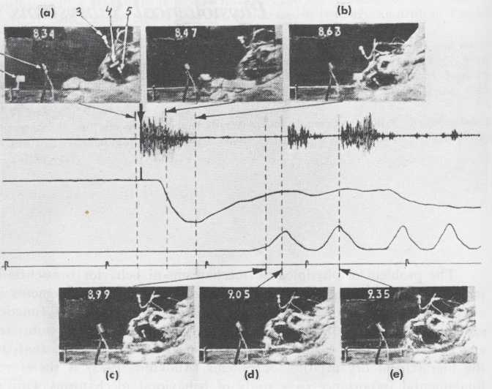
Figure 12.1. Synchronous cinematic and photoelectric recording of the motor components in a single food-acquisition act. (A) Recording of noises during presentation of food (left) and taking of food (right). When the food presentation was turned on, an accompanying clicking sound served as the start stimulus for the behavioral act. From now on this is shown by an arrow. (B) Recording of head movement/downward deflection of the pen—rapid phase of movement; upward deflection—slow phase. Between those phases is a horizontal "plateau" section of the curve that corresponds to the cessation of head movement. (C) Recording of the vertical component of lower jaw movement (lowering the jaw corresponds to an upward shift of the pen). (D) 500 msec time marker; (a)-(e), individual movie frames. Numbers in the frame corners—time in seconds. The dotted lines indicate the times in the recording that correspond to frame time of the arrow. Designations: (a, 1) movable pin with the piece of carrot; (a, 2) photoelectric plate; (a, 3) cranial-fastened light source with the distance between the cranium and plate (a, 2) indicated with respect to changes in the plate's photo EMF; (a, 4) photoelectric plate fastened to the nasal bone; (a, 5) light source fastened by an implanted wood screw to the lower jaw. The photo-EMF of the plate (a, 4) changes with movements of the lower jaw. The representation in (b) is blurred because of the high speed of movement. The same is true for (c) which corresponds to the "plateau," a clear representation. The maximum opening of the mouth is achieved directly after (d) and the taking of food occurs after (e), which corresponds to the second taking of food, at which time gnawing occurs.

12. Organization of Physiological Subsystems in Food Acquisition Behavior
179

microphone recording of the sounds made by the rabbit's taking the carrot with its teeth. The lower jaw movements were recorded by a photoelectric method that we devised. The head movements were also recorded photo-electrically. Synchronous film recordings of the movements were made in some acts (Figure 12.1 [a-e]). Intramuscularly implanted bipolar wire electrodes recorded the electrical activity of the m. splenius and the masticatory muscles mm. masseter p. prof., mylohyoideus, digastricus, and pterygoideus lateralis. An eight-channel "Nikhon-Koden" polygraph was used to record electrical muscle activity, head and lower jaw movements, and the achievement of the end result.
As an illustration of "motor system"-related cells, recordings were made of the anterior portion of the motor cortex whose stimulation produced well-defined masticatory movements (Sumi, 1969). Also recorded were the neuron activity of the trigeminal mesencephalic nucleus (trigeminal mesencephalic neurons) that are the first-order sensory neurons that send out the peripheral process to the proprioreceptors of the masticatory muscles, and the firing activity of a number of mesencephalic neurons. The cells that were recorded in corresponding coordinates (P—12,0; H—13; OL—1,5-2,5 of the stereotaxic atlas) (McBride 8c Klemm, 1968) were identified as TMS (trigeminal mesencephalic) neurons because of the relationship between their activity and the masticatory cycles and because of responses to palpation of the masticatory muscles and to direct electric stimulation of the m. masseter. The position of the microelectrode track was controlled morphologically. The experimental data were processed on a laboratory minicomputer.
Experimental Results and Discussion
An analysis of the cinematographs indicates that the first component of the rabbit's movement toward the carrot was a rapid lowering and forward extension of its head (Figure 12.1[b])—the "rapid phase." The lower jaw did not leave the rest position during this phase of the movement with the exception of the development of "microchews" (see Figures 12.2[1,A], 12.3[1,A]) that we identified as the initial consummatory act according to Craig (1918). The lower jaw's fixation was due to the stress created by the masticatory muscles during the head's rapid movement, at which time the muscles exhibited low-amplitude tonic activity. When the minimum distance was reached between the food and the head, the latter's movement slowed markedly; after that movement ceased, the "slow phase" of the movement evolved for a 30-80 msec "plateau" that consisted of the coordinated opening of the mouth and the movement of the head. Consequently, the buccal orifice was placed over the carrot (Figure 12.1[c]), and the food was taken (Figure 12.1 [d,e]—secondary food take).
A significant degree of variability was found in the means of achieving

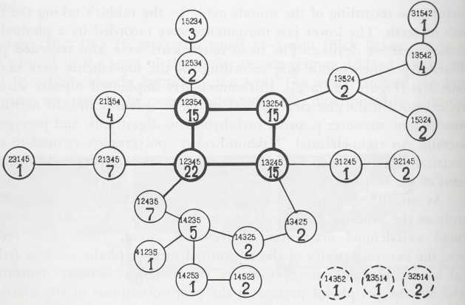
A

В
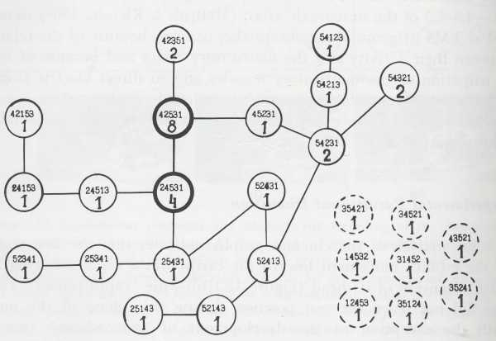
Figure 12.2. The association between the neuron activity of the anterior-lateral cortex (I) and the midbrain (II) and the implementation of the entire behavioral act (A) and with a separate phase of movement (B). Designations: (I, B) neuron activation of the an-teriolateral cortex occurs when the head is lowered only in (a) the "standard" behavioral act, but not when (b) the food is taken from the experimenter's hand. The time marker in (A) is 100 msec; in (B) is 250 msec. (II, B) Activation of the mesencephalic neuron occurs only when the head is lowered in (a) the "standard" behavioral act, in (b) "background" lowering, and even (c) during defensive integration; that is, during forcible lowering of the head. Time marker is 100 msec. Designations 1, 2, 3, and 4, are the same as Figure 12.5.

12. Organization of Physiological Subsystems in Food Acquisition Behavior
181

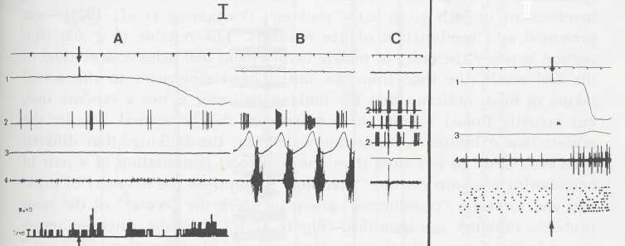

Figure 12.3. II
Figure 12.3. Comparison of the link between the activity of a TMS neuron (I) and anteriolateral cortex neuron (II) and the mouth's opening and closing during mastication and when these movements are involved in the taking of food. Designations: (I) similarity in TMS neuron activation during movements of the lower jaw in (A) the "standard" act of taking food, and (B) in chewing, (C) activation recording of the same neuron during intramuscular stimulation of the m. masseter, and (D) during palpation of the m. masseter. The time marker is 100 msec. (II) The activity of the anteriolateral cortex neuron is exclusively timed with the first opening of the mouth for taking food in a "standard" behavioral act (А, В, С). (C) represents the taking of food with subsequent gnawing and regular chewing. (D) The rabbit leans toward the food without taking it—activity is absent. Of course, the relation of a neuron's activity to a specific level of organization does not mean that there is no link with another level. Thus, the neuron activity that is being compared with an entire behavioral act (see text) also depends on the structure of the movement with which it coincides in time. See the change in the neuron activity during the "extended" opening of the mouth as shown by the arrow in (C). The jaw movement and EMF activity, characteristic of food taking, was observed only after the interval indicated by the arrow. The time marker is 250 msec. The designations 1, 2, 3, and 4 are the same as in Figure 12.5.
the end result of the rapid phase—maximum approach of the head to the carrot—and the end result of the slow phase—coincidence of the buccal orifice and food. We mean by the means of achieving the end result that activity "which a given system manifests externally and which is formed in the course of selecting this system from among many other possible activities" (Anokhin, 1973, p. 80), or the selection of the system's "degree of freedom." The variability in the degree of freedom was not chaotic or a simple manifestation of stochasticity. Concise regular characteristics were identified in their distribution.
After discovering that the sequence in which the muscles are involved in the rapid phase of a movement changes from act to act, for the sake of a more convenient analysis of the order of their involvement, we assigned the numbers 1, 2, 3, 4, 5 to mm. masseter, digastricus, mylohyoideus,


182 Yu. I. Aleksandrov, Yu. V. Grinchenko
splenius, and pterygoideus lateralis, respectively. Thus, the order of muscle involvement in each given act—"ranking" (Vartazarov et al, 1975)—was presented as a combination of five numbers. The reliable (p < .02) connection between the order of muscle involvement and achievement time of the end result (the time from the initial head movement to the actual taking of food) indicates that the ranking indicator is not a random one, but actually linked to the characteristics of the behavioral act. In the rabbits that exhibited a stable automated act, the rankings that differed from each other by not more than one reciprocal permutation of a pair of neighboring elements (by one "inversion") comprised the majority of rankings and formed a "coordinated" group in which the "center" of the most probable rankings was identified (Figure 12.4[A]). In the situation represented in this figure, only three rankings out of 119 observations "fall out." They cannot be approached through a continuous inversion chain. One can see fundamental differences in a comparison of this characteristic distribution to those identified in the case of the uncoordinated behavioral act (Figure 12.4[B]). That is, the "fallout" rankings here include 8 out of 39 observations. This is a significant difference, particularly if we consider that an increase in the number of observations in an "unbalanced" process leads to an increase in data straggling. Thus, the degree of freedom distribution turns out to be linked to the degree of the behavioral act's automation and the extent of its coordination.
An analysis of the variability of the means of achieving the result of the slow phase indicated that the stabilization of the head's position before the food was taken occurs at a rather fixed time interval after the maximum opening of the mouth—0-50 msec in 80-90% of the cases for various rabbits. The link between the onset of the head's slow movement following the "plateau" and the onset of the mouth's opening was significantly less rigid—the relative variation interval of these factors exceeded the aforementioned interval by three to seven times. The examined indices, like the rankings, are variable but are not random. The correlation between the onsets of the head's movement and the mouth's opening is reliably (p < .05) linked to the size of the carrot. When a small piece of carrot was presented, the head movement began later than it did when a larger piece was presented.
The appetent phase can be singled out in a "microethological" approach to analyzing the taking of food—movement towards the food and the consummatory phase—the eating of the food following the taking of food. Thus, the decrease we noted in the variability of the link between the subsystems of head and lower jaw movements during the approaching result of the act, that is, the taking of food, turns out to be comparable to the decrease observed by ethologists in the variability of appetent behavior as the consummatory act draws near (Tinbergen, 1955). Consequently, the variability in the degree of freedom is an index that is characteristically
Figure 12.4. Distribution of rankings in the coordinated (A) and uncoordinated (B) acts. The small numbers in circles correspond to the numbers of the mice (see text). The large numbers inside the circles signify the number of observations for a given ranking. The boldface circles signify the center of the coordinated group. The dotted circles on the lower right are the "fallout" rankings. See text for details.
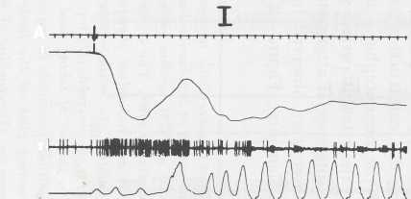
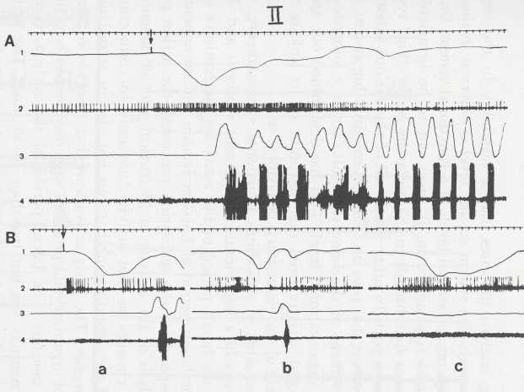
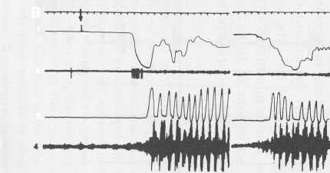
А
1
»\
3
в
1 2 3

184
Yu. I. Aleksandrov, Yu. V. Grinchenko

linked to the whole behavioral act and changes in time as the behavior evolves.
The preceding analysis indicates that a variability in the means of achieving the end result of a system on any level is observed in the course of examining various organizational levels of a functional system. But when a system is examined as a subsystem, it turns out to be invariable with respect to the place of its subresult in the hierarchy of the "big" system of which it has become a part. In other words, all of the various suborganiza-tional forms of elements that play an identical role in a big system, that is, enhance the achievement of the same subresult, act as a subsystem in a system of a higher organizational level. This has determined our approach to analyzing neuronal activity from the viewpoint of its link to various organizational levels of an elementary behavioral act.
From the viewpoints of Anokhin's functional system theory, the organizational processes of a behavioral act—afferent synthesis and decision making—occur in the latent period of the actuating mechanism's involvement, that is, in the latent period of EMG activation and movement whose development corresponds to the realization processes—the action program Shvyrkov. An analysis of the activity of 53 cortical and 50 mesencephalic neurons disclosed changes in that activity, not only in connection with the functioning of the actuating mechanisms but also in accordance with organizational processes. The early activations that coincide in time with the development of organizational processes were observed in 8 cortical and 22 mesencephalic neurons. The latent period of the early activations of the motor cortex neurons was not less than 40-50 msec. The activations varied with respect to the number of impulses and the latent period. The identification of those activations necessitated the construction of post-stimulus histograms. The early activations of the mesencephalic neurons were marked by a high degree of stability, and their latent period was significantly less than the 7 msec minima. Warranting special attention is the fact that short latent activations of 16 to 32 msec were observed in 3 out of 16 TMS neurons (identified proprioceptive elements). Figure 12.5 illus-
Figure 12.5٭. Changes in the activity of the trigeminal-mesencephalic neuron (I) and an individual motor unit of m. masseter (II) in the latent period of a behavioral act. (I, A) top: Recording of a separate act; bottom: histogram of a TGM neuron activity, constructed from the time of the appearance of the feeder's starter click. The channel width is 1.25 msec. (B) Connection between the neuron activity and individual chewing cycles: (C) TGM neuron activity during the intramuscular stimulation. An inhibitory pause with postinhibitory activation, characteristic of spindle afferents, is observed. (II) top: Recording of the activity of two motor units of m. masseter in the act of taking food, bottom: rasters of impulse activity of a motor unit with low-amplitude potentials in sequential behavior acts. The rasters were constructed from the starting click of the feeder device. Designations: (1) head movement recording: (2) neuronogram; (3) recording of lower jaw movements; (4) m. masseter EMF. The time marker is 100 msec.
٭Рисунок находится в конце статьи (Fig.12.5. is in the end of the paper)

186
Yu. I. Aleksandrov, Yu. V. Grinchenko

trates the activity of a TMS neuron that exhibited activation with a 32 msec latent period after the click and before the beginning of movement and EMG activation, and exhibited the properties of an afferent spindle during the tests. This is important in connection with the fact that the commonly accepted concept on proprioceptor function presumes that their activity is analyzed only in connection with the functioning of the actuating mechanisms. The latent period of the behavioral act, that is, the time required by the processes of afferent synthesis and decision making, has not been recorded by even the investigators studying not cyclic and imposed movements but singular arbitrary ones. Moreover, activity of the proprio receptors in this interval has not been analyzed.
The presence of an early activation in spindles is in agreement with data on the possibility that skeletal motor activity is surpassed significantly by spindle activity (Matsunami, 1972), and with the data on the activation of spindles outside their "own" muscle (Burg, Szumski, & Strupler, 1974), as well as the data on the appearance of gamma-activation with a latent period of 18 msec in response to a conditional defensive click-stimulus (Buchwald, Beatty, Eldred, 1961). The appearance of early activations of TMS-neurons in the interval corresponding to the development of the behavioral act's organizational processes confirms Ganit's (1975) hypothesis on the connection between spindle activity that occurs before an arbitrary movement and the arbitrary act's preparatory processes. The changes that occur in the alpha-skeletal motor activity that were identified in an analysis of individual motor unit activity (Figure 12.5[II]) apparently should be associated with those preparatory processes.
An analysis of the firing of cortical and mesencephalic neurons that are related to actuating mechanisms indicated that the neuron activation of both those structures can be time-lined to both the entire act (Figure 12.2 [I,A]; [II,A]) and to a separate movement (Figure 12.2[I,B]; [П,В]). A study of the activation properties related in time to individual movements disclosed significant differences between the cortical and mesencephalic neurons. The cortical cells were activated in relation to a given movement, as a rule, only when it was involved in strictly defined behavior (Figure 12.2 [I,B]). In the case where an activation was extinguished when there was a change in behavior, it underwent a fundamental reorganization. On the other hand, mesencephalic neurons were activated in a similar fashion in connection with a given movement in different behavioral situations (Figure 12.2[II,B]).
In order to study that difference in detail, a special comparison was made between the neuron activity of both structures during the opening and closing of the mouth in the chewing and gnawing processes, and when these movements were involved in the behavioral act of taking the food. Out of the 17 mesencephalic neurons examined for this purpose, the relationships that were exhibited between neuron activity and the opening

12. Organization of Physiological Subsystems in Food Acquisition Behavior
187

and closing of the mouth in chewing were maintained during the taking of food in 13 neurons, although there may have been some modification of activity in the latter case that is related to changes in the characteristics of the behavior itself (Figure 12.3[I]). Out of nine cortical neurons in which a link with individual chewing cycles was observed, in only three neurons did that link remain more or less constant when the jaw's movement was involved in the behavioral act. The activity of the remaining neurons changed fundamentally. Moreover, the activations of seven cortical neurons, consisting of one or several spikes, were related exclusively to the opening of the mouth in order to take the food, and were absent in all of the other animal's movements, including the gnawing and chewing of food, at which time the mouth was already opening and closing (Figure 12.3[II]). In spite of cellular differences of the examined regions, there were elements in each of them whose properties corresponded to the total cellular characteristics of another region.
Thus, most neurons in the cortex whose activity was time-linked to even the implementation of a separate movement exhibited a dependence upon the entire act. This dependence is the link that was identified during the involvement of a given movement in strictly defined behavior. Characteristic property of the mesencephalic neurons that were firing in connection with a specific movement was the retention of that bond as the utilization of a given movement was affected in different ways. The data we have obtained give us grounds for saying that activity of the cortical neurons is chiefly related to the organizational level of a behavioral act, and that the activity of mesencephalic neurons is primarily related to the organization of individual subsystems.
Conclusions
- The functional system of any organizational level is variable in
analyzing the means for achieving its result—degrees of freedom.
The degrees of freedom distribution is connected with the charac
teristics of a behavioral act. The number of a system's degrees of
freedom decreases by the time the system's result is achieved. A sys
tem cannot be distinguished through morphology. A system can be
identified only "from the top," that is, by determining the position
of its result in the hierarchy of the "big" system's results, into which
system it has been included as a subsystem.
- Motor cortex activity and proprioceptive afferentation which, ac
cording to traditional concepts, are linked to the actuating mecha
nisms of behavior, are also essential to the organizational processes
of a behavioral act, that is, afferent synthesis and decision-making.
- The activity of different neurons that fire at the same time of a be-

188
Yu. I. Aleksandrov, Yu. V. Grinchenko

havioral act (e.g., during the first opening of the mouth for taking food) can be related to various hierarchical organizational levels of a behavioral act's actuating mechanisms.
ACKNOWLEDGMENT
The authors are grateful to N. G. Gladkovich for his assistance in morphological control.
REFERENCES
Aleksandrov, Yu. I., & Grinchenko, Yu. V. Method for the photoelectric recording of
lower jaw individual components of masticatory movements. USSR Physiology Journal,
63 (No. 7), 1062. (In Russian) Anokhin, P. K. Fundamental problems in the general theory of functional systems. In
Principles of the systems organization of functions, 1973, p. 5. (In Russian) Anokhin, P. K. The Problem of decision-making in psychology and physiology. Problems
of psychology, 1974, (No. 4), 21. (In Russian) Buchwald, J. S., Beatty, D., Eldred E. Conditional responses of gamma and alpha moto-
neurons in the cat trained to conditioned avoidance. Experimental Neurology, 1961,
4, 91. Burg, D., Szumski, A. J., Strupler, A., & Velho F. Assessment of fusimotor contribution to
reflex reinforcement in humans. Journal of Neurology, Neurosurgery, and Psychology,
1974 (37), p. 1012. Craig, W. Appetites and aversions as constituents of instincts. Biological Bulletin of
Marine Biology Laboratory, 1918 (34), 91. Granit, R. The functional role of muscle spindles—facts and hypotheses. Brain, 1975, 98,
53. Matsunami, K., & Kubota, K. Muscle afferents of trigeminal mesencephalic tract nucleus
and mastication in chronic monkey. Japanese Journal of Physiology, 1972, 22, 545. McBride, R. L., & Klemm, N. R. Stereotaxic atlas of rabbit brain. Communication in
Behavioral Biology, 1968, 2 (Pt. A), 779. Shvyrkov, V. B. On the relationship between physiological and psychological processes in
the functional system of the behaviour act." Studia Psychology, 1977, 19, 82. Sumi, T. Some properties of cortically evoked swallowing and chewing in rabbits. Brain
Research, 1969, 15, 107.
Tinbergen, N. The study of instinct. New York: Oxford Univ. Press, 1955. Vartazarov, I. S., Zharomskii, V. S., Gorlov, I. G., Sobinyanov, V. A., Khvastunov, R. M.
Methods of investigatory analysis. 1975. (In Russian)

