Neural Mechanisms of
Goal-Directed Behavior
and Learning
Edited by
RICHARD F. THOMPSON
Department of Psychobiology
University of California, Irvine
Irvine, California
LESLIE H. HICKS
Department of Psychology
Howard University
Washington, D.C.
V. B. SHVYRKOV
Institute of Psychology
Academy of Sciences of the USSR
Moscow, USSR

ACADEMIC PRESS 1980
A Subsidiary of Harcourt Brace Jovanovich, Publishers New York London Toronto Sydney San Francisco
A. P. KARPOV
Analysis of Neuron Activity in the
Rabbit's Olfactory Bulb during
Food-Acquisition Behavior
18
The assumption that perception constitutes an active process that must include efferent links is commonly recognized in modern psychology. However, until now, investigators have been "charting stimuli" in the course of studying any sensory processes, recording changes in some particular factors, and then calling this a "response."
All the studies that have been concerned with the neurophysiological mechanisms of olfaction have employed the traditional method of investigation that calls for the recording of an olfactory stimulus by olfactometers of various design or even the electrical stimulation of olfactory structures, such as various sections of the olfactory mucosa or the olfactory bulb, as well as olfactory analyzer pathways, which is then followed by the recording of "reactions" in some particular structure.
Under natural conditions, an organism is not subject to the effects of any particular stimulant, but rather it fixes events that occur in the environment. All of the events that are unexpected at any given moment induce a behavioral response of an orientational-investigatory nature or are ignored altogether. As early as 1947, R. R. Woodworth wrote that "perception is always prompted by a direct motive that is inherent in a given situation and which might be called a desire to perceive."
As seen from the functional system theory of P. K. Anokhin, information perceived by an analyzer is utilized to secure the systems processes of any particular behavioral act. Hence each stimulus whose information is used in a behavioral continuum has a double role. On the one hand, the stimulus is expected to be within the acceptor of action results; that is, it is
273
NEURAL MECHANISMS OF Copyright © 1980 by Academic Press, Inc.
GOAL-DIRECTED BEHAVIOR AND LEARNING All rights of reproduction in any form reserved.
ISBN: 0-12-688980-5

274
A. P. Karpov

the goal and result of one functional system, and, on the other hand, this stimulus is the trigger for developing an ensuing functional system (An-okhin, 1968; Shvyrkov, 1973, 1978).
The study of the neurophysiological mechanisms of olfaction has many aspects, one of which is how to utilize information about the environment in the system's mechanisms of behavior. The task of this study is to try to explain how the neuron activity of the olfactory bulb is organized in food-acquisition behavior that is guided by olfaction.
The methods we used were determined by methodological prerequisites. The work was done on rabbits in free behavior. We selected a form of animal behavior so that a "scent stimulus" was not presented to the rabbit, but rather the rabbit itself would try to obtain the scent by its own actions. For this purpose we made a special chamber-cage, to whose anterior walls we attached a food box divided into three sections (Figure 18.1), each of which was a pencil box. Some kind of aromatic substance or food was placed into the extreme left or right boxes. The boxes were closed by rubber band tension. In order to prevent the rabbit from prematurely recognizing the food box's contents by its odor, air was constantly withdrawn
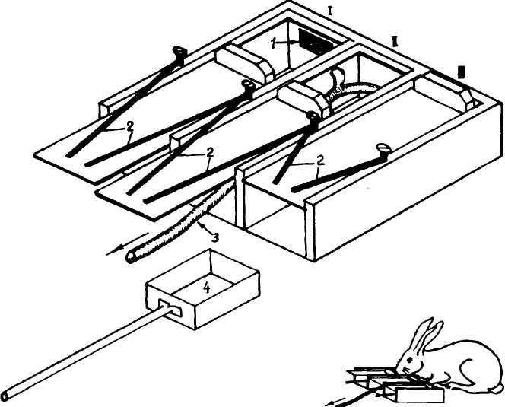
Figure 18.1. Design of food box for studying food-acquisition olfaction-directed behavior. Bottom right: Rabbit examines one of the food box sections. Designations: (I, II, III) sections of the food box; (1) photoelectric plate; (2) elastic bands; (3) ' ust pipe of water-jet pump; (4) removable food box.

18. Neuron Activity in Rabbit's Olfactory Bulb in Food Acquisition 275
from the boxes by a water-jet pump. The dynamics of the boxes' opening and closing was recorded photoelectrically.
As a preliminary step, the animals were trained to open the box covers and obtain food. To do this, the rabbit had to push open the box cover with its nose and take the food, if there were any there. When the box was empty or when it contained some substance with a repulsive odor (2% ammonia solution, 4.5% vinegar or virine of other rabbits), the rabbit was trained to release the cover and examine another section of the food box. The contents of each pencil box were changed by the experimenter in random order. The rabbit usually consistently examined the sections of the food box until it found the food (pieces of carrot or cabbage). When the rabbit examined the empty food box or the one containing substances with repulsive odors, it drew back the pencil box covers a total of .5-2 cm and then released them. This is proof of the fact that the rabbit is guided in his behavior only by olfaction when it cannot see the contents of the food box or examine it with its whiskers. When the rabbit detects food odor, it draws back the cover again and lowers its snout into the food box.
During the preceding described behavior, we recorded the overall electrical activity of the olfactory bulb, the activity of individual nerve cells of the olfactory bulb, as well as respiration. Recording respiration was essential to solving the problems at hand, because the respiratory movements accomplish the delivery of aromatic substance molecules to the olfactory mucosa. In addition, these movements apparently perform a function in olfaction that is analogous, for example, to eye movements in visual perception. Respiration was recorded by a photoelectric sensor sewn into the trachea.
The experimental data were processed by plotting histograms for neuron activity and averaging the overall electrical activity of the olfactory bulb and respiration relative to the noted behavioral instances: the opening of the food boxes, the closing of the boxes, the lowering of the animal's snout into the box to obtain food, as well as from the moment of inhalation, designated as "decisive." An accounting was made of the inhalation that was followed either by the food box's cover being drawn back or by the animal's lowering its snout into the food box. The data were processed on a laboratory minicomputer.
Before proceeding to a description and discussion of the results, we shall analyze in more detail the behavior already described. From the viewpoint of the functional system theory that behavior might be viewed as a large, complexly organized functional system whose viseful adaptive result is the satisfaction of food motivation. To achieve this, the rabbit completes an entire cyclic behavior. Figure 18.2 shows three single acts in which the rabbit opened the food boxes containing vinegar, virine, and carrots. Apparently, the goal of any opening act is either to detect food or detect its absence. This information is essential to the completion of the subsequent
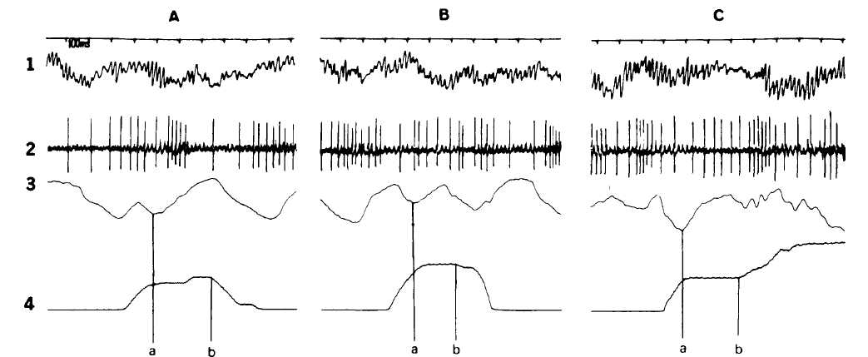
Figure 18.2. Overall electrical activity of the olfactory bulb. (1) Activity of olfactory bulb neuron; (2) and activity of respiration neuron; (3) during examination of food box with vinegar (A); food box with urine (B), and food box with cabbage (C). (4) Dynamics of food box opening, (a) is onset of "decisive inhalation," (b) is onset of releasing the food box covers (A) and (B) and the beginning of lowering snout into the food box (C).

18. Neuron Activity in Rabbit's Olfactory Bullb in Food Acquisition 277
acts—shifting to the neighboring box and opening it or lowering the snout into the box to get food. Thus, each sequential act of examining the food boxes also constitutes a complex functional system with its stagewise result.
Evidently, under the conditions of the described behavior, possible contact with a scent lasts from the onset of the decisive inhalation (point a in Figure 18.2) to the closing of the food box or the lowering of the snout into the food box (point b in Figure 18.2). Apparently, all the processes associated with making a decision about any particular scent occur during the time of one respiratory cycle.
From the viewpoint of the functional system theory, a respiratory act constitutes a functional system at the physiological level, whose useful adaptive result is the passage of a specific volume of air into the lungs. At the same time, each respiratory act is accompanied by the passage of aromatic substances contained in the surrounding air to the olfactory mucosa.
When the rabbit is resting in the cage, the olfactory information is probably an inevitable consequence or an incidental result of an inhalation's physiological system and is used as a component of situation afferen-tation in the afferent synthesis of current behavioral acts. The functional inhalation systems in current behavior are developed relatively independent of behavior, so that the same behavior act, such as the opening of the food boxes, for example, could begin in any phase of the respiratory cycle, as was observed in the experiments we conducted.
The time at which the food box is opened in food-acquisition behavior corresponds to the functional onset of the actuating mechanisms of the system of opening. The possibility of inhaling the air over the aromatic substance placed in the food boxes should be seen as the result of that system. One of the odors in that air is a result parameter of the functional system of inhalation that follows the functional system of opening. The functional system of inhalation at this time already acts as a functional system at the behavioral level, since the result of this system becomes a part of afferent synthesis, no longer as a situation component but as a trigger for the next behavioral act.
The experiments have shown that the time required for recognizing odors and for making a decision about a particular odor is about 250 msec on the average (the interval a-b in Figure 18.2). These figures are comparable to those indicated by other investigators as so-called reaction times to stimuli of other sensory modalities.
A study of the overall electrical activity of the olfactory bulb in the previously described behavior indicates that upon averaging various behavioral factors in an electrogram, one often detects a fluctuation in potential that is similar in configuration to the traditional evoked potential recorded by many investigators in various regions of the brain in response to stimuli from other sensory modalities. The upper curves 1 and 2 in Figure 18.3 (A, B, C) represent averaged recordings of the overall electrical

18. Neuron Activity in Rabbit's Olfactory Bulb in Food Acquisition 278
activity of the olfactory bulb, from the end of the "decisive" inhalation to the beginning of exhalation, during the rabbit's examination of the food boxes containing vinegar, urine, and cabbage (first curve is the bandpass from the top 200 Hz and the second curve is 36 Hz). One can see that the "evoked-potentials" type fluctuations in the olfactory bulb electrogram correlate with the respiratory cycle, and are apparently associated with the detection of olfactory signals for accomplishing food-acquisition behavior.
There have been quite a few studies of the so-called background activity of olfactory bulb neurons, as well as activity associated with the effect of olfactory stimuli, and there are presently a number of works in which recordings have been made of olfactory bulb neurons whose activity is associated with various phases of the respiratory cycle (Eksler & Safonov, 1975; Macrides 8c Chorover, 1971; Walsh, 1956; and others). Fifty-seven out of the 96 neurons that were recorded in our experiments exhibited that association. The remaining 39 neurons were fired with relative regularity, without any connection to the respiratory cycle. It is essential to note that we did not detect any primary association between the activity of "respiratory" neurons and a particular phase of the respiratory cycle. Besides, the correlation between neuron activity and any particular phase of the respiratory cycle did not remain constant. As can be seen from Figure 18.4, neuron activation in the animal's quiescent state, when the rabbit does "not behave" visually, is associated with the exhalation-inhalation period and a reduction in activity to the end of the inhalation and the beginning of exhalation. During the rabbit's exploratory behavior, when it is sniffing the chamber's walls and its respiratory movements are frequent and superficial, the firing peak of the same neuron is observed in the inhalation period with a maximum on the inhalation peak and with inhibition during exhalation (Figure 18.4B).
A change in activity in connection with the stages of food-acquisition behavior was recorded in neurons that fired in connection with respiration and in nevirons that were fired in relatively regular single impulses. Changes in the activity of ten olfactory neurons were observed in the period preceding the opening of the food boxes, as well as after the covers were released or the snout was lowered into the food box. The changes in activity that occurred during these periods could often be associated with a change in respiration and did not depend on the aromatic substance. During the same time, recordings were' also made of neurons whose activity during these periods changed specifically in relation to the substance. Thus, Figure 18.5 shows a well-defined activation after the food boxes with urine were closed (Figure 18.5B), whereas no such activation was detected after the empty food boxes and the food boxes with cabbage were closed (Figures 18.5A and C). Evidently, these changes in the activity were not associated with odor differentiation, since no decision was taken with respect to odor,
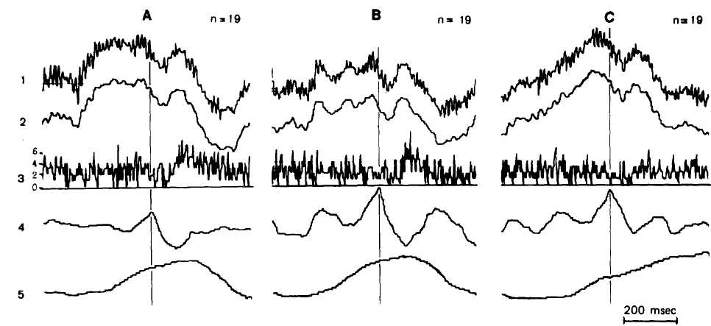
Figure 183. Coincidence of neuron (3) activation to negative fluctuation in an overall electrogram of an olfactory bulb (1, 2) and to respiration (4) during examination of the food boxes with vinegar (A) and with urine (B). Neuron activation was absent during examination of food boxes containing cabbage (C). Averaging of the electrogram, respiration and markings, and the plotting of neuron activity histograms were heavily relative to the end of the "decisive" inhalation.

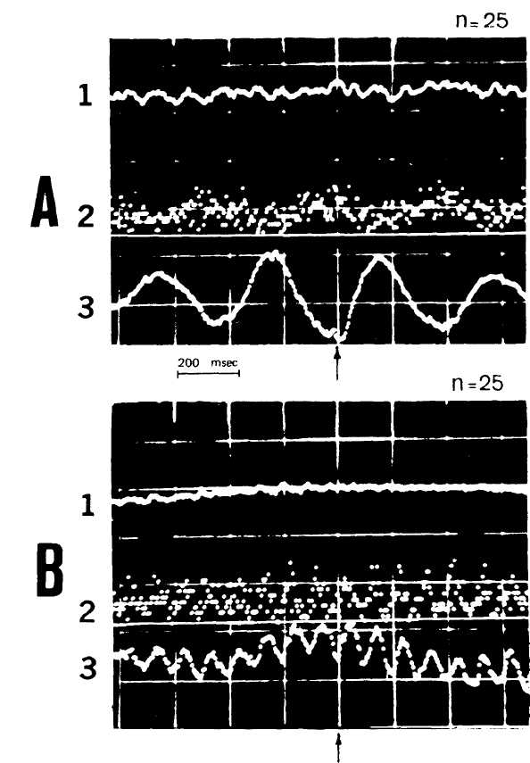
Figure 18.4. Change in the correlation of neuron activation during various aspects of behavior. (A) During the resting state of an alert rabbit; (B) during exploratory be-liavior-snifjing. Designations: (1) averaged EG recording of the olfactory bulb; (2) neuron activity histograms; (3) averaged recording of the animal's respiration.
but they were associated with the involvement of such neurons in the actuating mechanisms of olfaction-directed behavior.
When odor identification did occur and a decision was made with respect to that odor, an activity change was observed in seven neurons. Note that we did not find any relationship between the nature of these changes and any particular substance or substances of various groups (rejected sub-

281

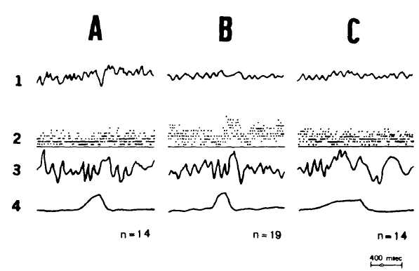
Figure 18.5. Association between olfactory bulb neuron activity and behavior directed by odor perception. Neuron activation after the closing of food box lid in box with urine (B). During the examinations of food boxes with cabbage (C), or examination of empty food boxes (A); neuron did not change its activity (A and C).
stances or food). Various neurons exhibited different forms of activity while the rabbit was examining food boxes with identical aromatic substances, and at the same time, different odors could change the activity of various neurons in an identical fashion. Thus, the neuron shown in Figure 18.3 (3) related its activity to the animal's respiration when it was examining the food boxes containing vinegar (Figure 18.3A) and when it opened the food boxes with urine (B). Thus, the neuron's activation corresponds to the end of exhalation and to the beginning of inhalation. Such activity was not observed when the animal examined the food boxes containing cabbage (Figure 18.3C).
Thus, the activity of olfactory bulb neurons in behavior does not constitute a "response reaction" to olfactoiy stimulation, but characterizes, the utilization of olfactory information in various mechanisms of the behavioral act's functional system. Apparently, the activity of olfactory neurons is determined by their simultaneous involvement in the functional system of respiration and in the system's processes of behavior. One would think, then, that the processes of odor recognition are not conditioned by the activity of specific detectors, but by a specific organization of the activity of many olfactory bulb neurons.
REFERENCES
Anokhin, P. K. Biology and the neurophysiology of the conditioned reflex. Moscow, 1968.
(In Russian) Eksler, N. D., & Safonov, V. A. The activity of olfactory bulb neurons, synchronized with

282 A. P. Karpov
respiration. Scientific Papers of Higher Institutions. Biological Sciences, 1975 (No. 4),
p. 39. (In Russian) Macrides, F., & Chorover, S. L. Olfactory bulb units. Activity correlated with inhalation
cycles and odor quality. Science, 1971, 175, p. 84. Shvyrkov, V. B. Neuronal mechanisms of learning as a component of the functional system
of a behavioral act. In Principles of the systems organization of functions. Moscow,
1973, p. 156. (In Russian) Shvyrkov, V. B. The functional system theory as a methodological basis of behavioral
neurophysiology. Progi'ess in Physiology, 1978, 9 (No. 1). (In Russian). Walsh, R. R. Single cell spike activity in the olfactory bulb. American journal of Physiology, 1956, 1$6, p. 255. Woodworth, R. S. Reinforcement of perception. American Journal of Psychology, 1974,
LX, p. 119

