Study of holiday representations among teens of Russia: Moscow, Elista (Kalmyk Republic) and Cossaks of Veshenskaya stanitsa

Margarita Volovikova, Svetlana Tikhomirova (Sveta@psycholras.ras.ru)
Institute of Psychology, Russian Academy of Science

Abstract
Prototype approach was applied for study holiday representations among teens of modern Russia. We analyzed more then 100 answers of the senior pupils of 15-17 years old, 40 Russian children from Moscow, 40 Kalmyks from Elista and 20 Don Cossacks from stanitsa Veshenskaya) to the questions of the form we developed. According to the data we received applying the content- analysis, the prototype of the holiday for teenagers from Elista and Russian Cossacks was New Year and Birthday for Russian teenagers from Moscow. Ethnic and religious holidays haven't become the prototype yet and International (Soviet) holidays are not the prototype anymore. New holidays involving ethnic holidays and international holidays have become popular among youth and teenagers.

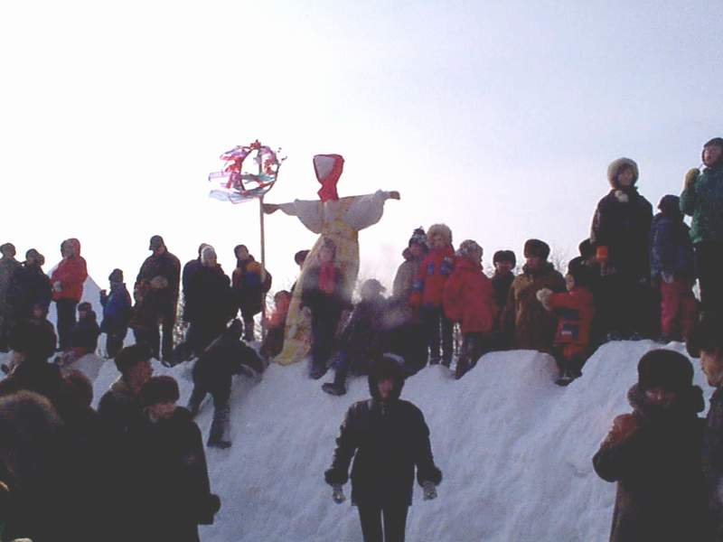 | Russian Holiday of MASLENITSA.  Spring, 2001
The theme we suggest to discuss – the psychology of the holiday- is rather original and new (and rather unexpected also) for the psychology of development. In spite of the fact that a person spends not so much time on holidays, we suppose that all deep processes of developing of the person are connected with the this phenomena that is both deeply personal and widely social. Children always experience positive emotions during the holidays. Our studies (carried out by Volovikova M., Thikhomirova S., 2000) has shown that the formation of the children’s representation of the “real”, “true” holiday takes its beginning at the very childhood. The earliest conscious recollections about the holiday can be related to the age of 5-7 years. Further, a holiday plays an essential role throughout all the life of the person as the incredible source of positive emotions and actions. A holiday enables to arise a great feeling of unity and give deep emotional uplifting. The public psychology of the people is vividly expressed in holidays. A holiday is the special means of gaining knowledge through getting the positive emotions without any parents’ pressure on a child.
A holiday is the form of ethnic and ethical education involving ethnic values, norms and etiquette. Besides it is obvious the special means of communication, interpersonal dialogue giving the possibility of self-expression and revealing of the personality. The huge potential of a holiday enables to decide many practical and vital problems (providing you use it very delicate).
In the ethnic tradition of Russians and other peoples living in Russia, representations of a holiday were traditionally connected with religious and national holidays. It happened so that the vast majority of religious holidays had been prohibited and the new so called International holidays introduced after the revolution of 1917, besides after 1991 year the attempts to return to the former ethnic and religious holidays had been fulfilled. In this connexion we consider the problem if all these changes have an effect on the representations of young people.
Our research was anticipated with the analysis of representations of the holidays in the Internet. It turned out that the quantity of the sites devoted to the theme of holidays has sharply increased during the last 2-3 years. It concerns both English-speaking, and Russian-speaking sectors of the Internet, although on such sites the very meaning of the word “holiday” has various hues. In Russian-speaking sector the holiday is usually connected with education and culture, in English-speaking - with business, sale of celebratory attributes and in latest time - with intercultural interaction in business (for example, if you plan the trip to another country it is quite useful to find out whether your visit coincides with some holiday in the country).
We observed the unique discussion about New Year holiday taking place during one of the Internet - forums. Participants of the discussion were young Russian women – emigrants living in Israel, USA, Canada, Germany, Northern Ireland, South Korea. They discussed the question: “Why is there now feeling of the holiday during the New Year in the mentioned countries?” ( In these countries people celebrate Christmas- rather unusual holiday for the Russians as there was no official holiday on Christmas in the USSAR).
Memoirs about the New Year were very precious and significant for emigrants from Russia (for example, could cause sadness or joy). They reflected if it was possible to return or reproduce the image of the holiday living in another country. Therefore they tried to create the atmosphere of Russian New Year with such essential attributes as fur-tree, champagne in midnight, Russian salad and movie traditionally shown at New Year eve “Destiny’s Irony”. However it was found out, that fur-trees didn’t have the same smell as it was in the childhood, they could not make their mind when to open bottles with champagne as according to the Russian tradition all the people of the huge country fill their glasses with sparkling champagne exactly at 12 o’clock in the morning under the striking of Kremlin chiming clock, the salad and film do not create the atmosphere of the holiday. Thus the following conclusion was made: if you want to have the real wonderful holiday you have to go to Russia and celebrate New Year there.
The analysis of a historical context has allowed us to assume, that the New Year holiday should take a special place among other Russian holidays. After the decree of tsar Peter I people start celebrating New Year on January, 1 instead of September, 1. There was a change of calendars after the revolution (from Julian to Gregorian) (so "old New Year" appeared - January, 14, and "new one" - January, 1,). The Christmas holiday was forbidden after the revolution, but apparently, adults and children still remembered it. It was extremely difficult to destroy the image of this wonderful sincere holiday. Therefore with symbolically and semantically changed attributes Christmas in Russian was turned into the celebration of New Year. As we see, New Year is not that important holiday in other countries as it is in Russia.
Russia is a multinational country. Peoples leaving in Russia are of different nationalities and confess various religions. The destiny of some peoples during the Soviet period was really tragic. Kalmyks were people who had been violently moved for some decades from their native land, though, truly speaking, allowed to return then. Anticipating our story, we’ll give the brief information about the history of these people.
Kalmyk people has a very tragic period in the recent history. Almost all the Kalmyks were sent to Siberia and Central Asia in December 1943. Deportation was dispersing, families were separated: husband, wife and child lived in different places; people were deprived of the language and cultural environment. Deportation was rather long - more than 10 years. In such conditions the preservation of ethnic identity is a phenomenon. There is the growth of ethnic consciousness in the early 90s supported by the President of Kalmykia: ethnic schools - licea were created, dancing and vocal ensembles were organized, the symbols of Buddhist culture appeared in the streets of Elista, ABC-book of Kalmyk language was issued.
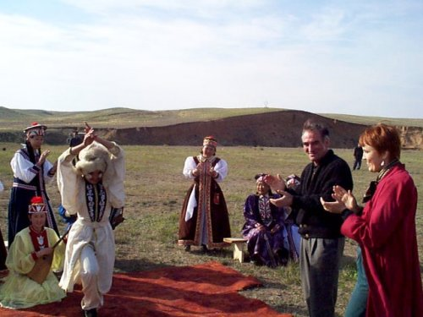 | 10y.o. girl dances the ethnic dance “Hare”. Holiday of Tulip in Kalmykian steppe.  Kalmykia is the unique center of Buddhist culture in Europe. Actually the population is not very big, about 180 thousand people, 120 thousand of whom live in the capital of Kalmikia- Elista. A natural landscape is the steppe caroled in many songs. Geographical remoteness from transport highways of Russia plays a significant role in cultural development of Kalmykia, creating natural isolation and the originality of Kalmyk culture
Dancing and singing performances on Saturdays and Sundays have become an interesting and bright event in life of the Kalmykian capital. A lot of people, of different ages and social groups come to the main square of Elista these days. Teenagers and young people use to spend their free time there. Kalmyk language was practically lost during the period of deportation; nowadays Russian is the real language of communication in Kalmykia. Ethnic revival begins with two basic events – the constructions of two temples: hurull (a Buddhist temple) and Orthodox Church, the second is the renascence of ethnic holidays.
This generation was born and brought up on the native Kalmyk lands, already after the repatriation. How is the feeling of the ethnic identity inherited and reproduced under such complicated conditions? Is the real the holidays really important in the development of ethnic consciousness? Our preliminary research (Volovikova M., Tikhomirova S., 2000) of people’s representations of holidays (Volovikova M., Tikhomirova S., 2000) has allowed to find out an interesting fact: an ethnic holiday in Siberia during the deportation is one of the brightest recollections of adults in Kalmykia. Nowadays the government tries to take some steps on restoration of ethnic culture in Kalmykia. Therefore the question is how do these actions of the government influence the youth of Kalmykia?
In other words this problem can be formulated as: are the special measures on preservation of love and knowledge of ethnic culture are effective when it concerns young people? As a whole questions, we took into the consideration the following questions as the basis of our studies:
- What representations of holidays do the modern youth have?
- If there are any regional and ethnic differences in representations of holidays of young people?
-What is the prototype of the real holiday for young people in Russia of nowadays?
Investigation
For the realization of our research work we had applied the questionnaire specially developed and tested by us. This questionnaire included the task to choose associations to the word "holiday", the request to describe especially memorized holiday and to try to explain, why exactly that holiday was special and unforgettable for examinees. We also inquired about the age and gender of the examinee and considered the age the recollections about the holidays were connected with. The filled questionnaires were analyzed applying quantitative and qualitative methods. We also used the content-analysis, the microsemantic analysis (Brushlinskiy ,1996), as well as the calculation of % of named associations in each of the researched groups of teenagers, and also % of mentions of every concrete holiday.
Examinees: 100 senior pupils (15-17 years old, 40 Russian from Moscow, 40 Kalmyks from Elista and 20 Don Cossacks from stanitsa Veshenskaya- the native land of writer Sholohov), boys - girls - in equal shares.

Results of the analysis
Data received during the analysis of associations with word "holiday" in various groups of senior pupils are given in table 1.
Table 1. Associations with the word “holiday”
Mentioned associations with the word “holiday” in the answers of teenagers | % Of pupils from Moscow mentioned the given association | % Of pupils from Elista mentioned the given association | % of pupils from stanitsa Veshenskaya mentioned the given association
Fun | 62,5 | 41,9 | 31,8
Joy | 22,5 | 39,5 | 19
Communication with friends | 32,5 | 32,6 | 3,2
Receiving presents | 30 | 20,9 | 3,2
Holiday dishes | 10 | 0 | 3,2
Rest, day-offs | 12,5 | 44,2 | 3,2
Beverages | 20 | 11,6 | 0
Music | 10 | 7 | 1,6
A lot of people | 7,5 | 9,3 | 3,2
Dancing | 0 | 14 | 0
Celebration | 0 | 0 | 4,8
Besides such words as "guests”, "fuss", "dances", "family" ("mum") "interest", "pleasure", "entertainments" and some other associations were mentioned. As we see, as a whole there are some common points and distinctions in associations with the word "holiday" in all three mentioned groups. However there are evidently two leading theme. These are "fun" and "joy". It is interesting that teenagers ( as well as adults) mentioned both of these words feeling at the same time a difference between the meanings. The word “joy” has deeper meaning than “fun”.
It is also interesting, that some associations mentioned in one group of teenagers, were never mentioned in another (so young Cossacks had never mentioned words "binge" though there are no any prohibitions of that king in the stanitsa). Appreciably, that associations depends much on the habitual way of spending free time by young people. For example, the word “disco” is not connected with the image of the holiday of Muscovites and young Cossacks, but it is mentioned by young Kalmyks ( perhaps, because of their originality). It is rather difficult to explain the priority of such kind of associations with the theme “holiday” of pupils from Elista ( maybe, it happened casually, they were tired of their studies and dreamt about holidays). We assume, that local and national features influence the associations greater; although we expected some unity concerning the prototype of a holiday of children living in one country. We supposed, that such holiday would be New Year (with all specific features of "Russian" New year "we mentioned in the beginning).
As whole our assumption have been confirmed. Here is the ratio of the main holidays mentioned in different groups of children.

Table 2. The main holidays mentioned by teenagers

The name of the holiday | % Of the total amount of holidays mentioned by teenagers from Moscow | % Of the total amount of holidays mentioned by teenagers from Elista | % of the total amount of holidays mentioned by teenagers from stanitsa Veshenskaya
New Year | 30 | 46 | 52,4
Birthday | 32,5 | 30 | 1,6
Name Day | 0 | 0 | 9,5
St Valentines Day | 3,2 | 0 | 7
Christmas | 0 | 0,8 | 1,6
May, 1 | 0 | 0,8 | 0
May, 8th | 0,8 | 0 | 1,6
Sholokhov Spring | 0 | 0 | 19
Content-analysis showed that the prototype of holiday is NEW YEAR for Kalmykian teens and Don Cossaks’s teens from Veshenskaya Stanitsa. As for Russian teens the New YEAR shared with BIRTHDAY one of the first places. Ethnic and religious holidays don’t become a prototype of holiday yet, and “soviet” holidays already are not a prototype of holiday. New holidays with elements of ethnic holidays become popular among teens and adolescents. One of such holiday is “Sholokhov’s Spring” that takes place on the home stanitsa of the famous writer. Sholokhov Spring takes the great place (after NEW YEAR) in the children’s memories. This holiday avoided the situation of “official” celebrating when all people are divided on two groups – executing and passive observing. Let we see on the stories of teens:
“It was undesirable event. There were a lot of people on the streets, all of them smile and congratulate each other…” (f., 16y.o.) “ It was the great firework, friendly relationships, many old friends” (m, 16 y.o.) Firework impressed all respondents. It’s necessary to imagine the landscape of the Veshenskaya Stanitsa – the bight of Don river, the high shore of the river and the broad expanse. “Most of all I remember the firework. Different colors are so wonderful on the dark sky. It’s impossible to forget” (f., 17 y.o.) The teens stories about impressive holiday are so bright and detailed that they allow “to see” what happened during the celebration in Stanitsa Veshenskaya: “The first day there is demonstration on the square – Cossak’s presentation (posidelki). In the evening we have a holiday on Don’s shore. The firework is in the evening too. I’s very beautiful. Then the celebration for young people…” (f., 17 y.o.) “There are a lot of people on this holiday, merriment, many groups of different ethnicity, we communicate and get new acquaintance”(f.,16 y.o.). On the question “what makes this holiday photographed in memory” one respondent answered: “Memorized because is was jollily. I didn’t with this holiday to finish”.
“Sholokhov Spring” arose after the death of the famous fellow-countryman Sholokhov who was the writer and gave the name to this holiday. The memory about Sholokhov surely plays the associative role. We think the other reason for viability of this new holiday is connected with the fact that this holiday continues the old forms of the holiday behavior but with new content. It was usual manner to celebrate and to communicate, to exchange news, to exchange visits, to make special holiday table on the streets near every house. It’s from the ancient times that holidays means common merriment that leaves homes for the streets. Dances, singing songs, concerts satisfied the existential need of communication with gladness. The new (by the name) holiday appeared the old traditional one by form so it heir the popularity of the previous holidays. We have to note that children of Veshenskaya are not spoilt by impressions on the one hand. So firework ( especially on the beautiful Don shore – “The Quite Don”) became unforgettable event. On the other hand they can become the participants of the holiday events because they know how to sing and to dance. There are a few folk music groups with children studio among them.
So the main existential meaning holiday is first of all getting the experience of communication in gladness. If this substance is absent the personality of adolescent suffers deeply, in this case he/she misses something essential for his/her normal development. Traditional culture has this important quality of holiday. Nevertheless we can observe the dynamic changes here.

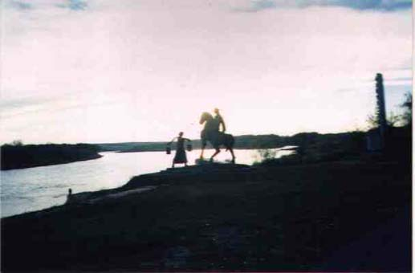 | 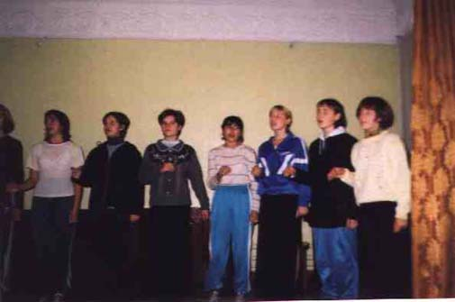
Monument of heroes of “Quite Don” by M.Sholokhov in stanitsa Veshenskaya | Teens Folks Group of stanitsa Veshenskaya. October, 2000

Modern adolescents from Kalmykia appeared to be predisposed to new international holiday, they pointed West European holiday of Santa Valentine. “Favourer of the beloved” Santa Valentine become popular also among population of big Russian cities. We suppose that the further process of internationalization of holiday will be more apparent. So now only in 1992 we get new fashion on Scottish holiday “Santa Patrick”.

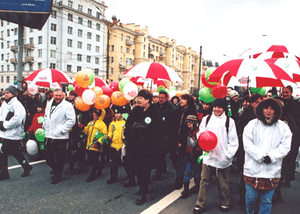 | On 15 March 1992, thousands of delighted Muscovites lined Novy Arbat (central street of Moscow) to witness the first St. Patrick's Day Parade in the Russian capital's history.
We can’t exclude that prototyping image of NEW YEAR became so popular due to it’s international character. It is reality that modern young generation only now get knowledge about connection between NEW YEAR and Christmas. The main moment stays the fact that on the 12 o’clock all population of Russia and all over the world (in order to time zones) are joined in one wish – to congratulate and to wish each other happiness and new stage of life in New Year.

Conclusions
- The ability to be joyful, to realize the symbolic sense of vital events is
inherited through the celebratory culture.
- The internationalization of representations of the real holiday is taking
place in teenagers' environment.
- Modern holidays become popular if they involve the ethnical traditions of
the culture on the given region or place.
- New Year is the prototype of the real holiday for different ethnic groups
of teenagers in Russia.
- Associations of young people from different regions and ethnic groups
with the word "holiday" have both common points and differences. As a whole there is a common mere verbiage: joy, fun, good mood, feast, meeting with friends, a lot of people, recreation, etc.

?The work was supported by INTAS (INTAS-OPEN-97-1363) and Russian Humanitarian Scientific Fund (N 99-06-00251a) Presented at Xth European Conference on Developmental Psychology. Uppsala, Sweden, August 22nd-26th, 2001.

