Alexandrov, Yu.L, Grechenko, T.N., Gavrilov, V.V., Gorkin, A.G., Shevchenko, D.G., Grinchenko, Yu.V., Aleksandrov, I.O., Maksimova, N.E., Bezdenezhnych, B.N. & Bodunov, M.V. 2000 Formation and realization of individual experience in humans and animals: A psychophysiological approach.
In: R.Miller, A.M.Ivanitsky & P.M.Balaban (eds.) Conceptual advances in brain research. . Vol. 2. Complex brain functions. Conceptual advances in Russian neuroscience, pp. 181-200. Harwood Academic Publishers.
10 Formation and Realization of Individual Experience in Humans and Animals: A Psychophysiological Approach
Yu. I. Alexandrov, T. N. Grechenko, V. V. Gavrilov, A. G. Gorkin, D. G. Shevchenko, Yu. V. Grinchenko, I. O. Aleksandrov, N. E. Maksimova, B. N. Bezdenezhnych and M. V. Bodunov
Laboratory of Neural Basis of Mind, Institute of Psychology, Russian Academy of Sciences, Moscow, Russia nyualex @psychol. ras. ru
A systemic methodological approach to psychophysiology is described. In the framework of this approach a wide range of experimental data are analyzed, including the results of neuronal recordings in vitro, and in awake normal and pathological animals, performing both complex instrumental and simple behavioural acts. Also included are data from experiments with human subjects in tasks involving categorization of words, skilled performance, participation in game activity in groups, and completion of psychodiagnostic questionnaires. On the basis of these analyses, qualitative and quantitative descriptions of the principles of formation and realization of individual experience are suggested within the framework of a unified methodology.
KEYWORDS: psychophysiology, functional system, individual experience, systemogeny, learning. memory, humans, animals, neuronal activity, event-related potentials, individuality
1. INTRODUCTION
Discovering the principles of organization of behaviour, based on experience accumulated by an individual, and the laws governing the formation of such experience is a multidisciplinary task. This general problem poses the majority of the specific questions of psychology, neurosciences, developmental biology, and genetics. At the same time, the solution of the general problem can be based only on synthesis of the achievements of a wide range of disciplines. Such synthesis is hampered by obstacles resulting from attempts to create a unified description from diverse data relating to humans and animals, of an individual synapse, or a neurone, or a whole organism, complex unlocalized mental processes and local physiological phenomena. The aim of the present article is to suggest a system of views, based on the literature and our own experimental data, within the framework of which such obstacles may be overcome.
In order to describe the cerebral basis of formation and realization of individual experience (IE), we define first the elements of IE (EIE). Today only a few researchers question the conclusion that the "properties ... of a brain are emergent" and are "systemic", not "just the sum ... of properties" of neurones, but a specific quality that emerges as a result of "dynamic interaction" of neurones within the system (Mountcastle, 1995, p. 294).
181
182 Yu. I. Alexandrov et al.
Analysis of possible levels of behaviour suggests that the level of "a unified group of neurones" is the most elementary level of analysis where the corresponding behaviour may still be described as an emergent function (Bottjer et al, 1994). A cerebral equivalent of EIE, which is established during the formation of a new behaviour, and realized during its subsequent performance, may be defined as an organization of a group of neurones, constituting the corresponding system. The question of what is meant by a "system" must be answered before we can use an understanding of EIE to describe the formation and realization of IE.
From our point of view, the most well-developed and un-contradictory version of the systemic approach to analysis of neuronal basis of behaviour, is the theory of functional systems elaborated by P.K. Anokhin and his school (Anokhin. 1973). The major distinguishing characteristic and advantage of this theory is the definition of a system-creating factor—the result of a system, which is understood as a desired relation between an organism and environment, achieved through the realization of that system. In other words, the principal determinant of a system is an event which is not in the past with respect to behaviour, that is, a stimulus, but which occurs in the future, a result. Thus a system is understood as a dynamic organization of activity of components with different anatomical localization, the interaction of which takes the form of mutual facilitation, in the process of ensuring a result that is adaptive for an organism.
It was demonstrated that the mutual facilitation in achieving any behavioural outcome is ensured by uniting synchronously-activated neurones situated in different brain structures (Shvyrkov, 1990). There is increasing evidence for this suggestion (Bullier and Nowak, 1995). The evidence is also increasingly important for the understanding not only of a specific behaviour, but also of learning. The association of synchronously active cells may ensure the achievement of the result even during the first trial, and may serve as a base for further consolidation: "Neurons wire together if they fire together" (Singer, 1995, p. 760).
In addition to the systemic idea described above, another important premise of the theory of functional systems is the idea of development (Shyleikina and Khayutin, 1989). Both ideas are merged in the concept of systemogeny, which states that, during early ontogeny, those differently localized elements undergo selective and accelerated maturation that is essential for achieving the results of the systems, providing for the survival of an organism at the early stages of individual development (Anokhin, 1973). Nowadays it is commonly accepted that many regularities of modification of functional and morphologic characteristics of neurones, as well as of control of gene expression, serve as a basis for the formation of adaptive behaviour in adults, and are comparable to those found at the early ontogenetic stages (Anokhin and Rose, 1991; Bottjer et al., 1994; Singer, 1995). The idea that systemogeny takes place not only during the early ontogenetic period, but also during adult development was formulated within the framework of the theory of functional systems nearly 20 years ago (Shvyrkov, 1978; Sudakov, 1979). This idea arose because the formation of a new behavioural act is always a formation of a new system. Later it was suggested that an understanding of the role of different neurones in the organization of behaviour depends on the history of behavioural development (Alexandrov, 1989; Alexandrov and Aleksandrov, 1982), or in other words, the history of the successive systemogenies, and the system-selective concept of learning was inferred (Shvyrkov, 1986). The latter concept is in line with the modern idea of "functional specialization" which substituted the idea of "functional localization" (Mountcastle, 1995)
Formation and Realization of Individual Experience 183
and with the idea of the selective, rather than the instructive, principle of learning (Edelman, 1987). This concept considers the formation of a new system as the fixation of the stage of individual development—the formation of a new EIE during learning. The base of this process is the specialization of some "reserve" of (silent) neurones, but not the change of specialization of previously specialized units. Thus, the new system becomes an "addition" to the existing EIE (Shvyrkov, 1986, 1995). The selection of particular neurones from the reserve is governed by their individual features, that is, by the characteristics of their "metabolic needs" that are genetically determined. Newly formed systems do not substitute previously existing ones, but are "superimposed" over them; the appearance of neurones with new specializations results in the increase of the total number of units activated, whereas the number of neurones with old specializations does not decrease (Gorkin, 1988; Shvyrkov, 1986). The suggestions that the number of active neurones is increased during learning, and that learning involves new neurones rather than "re-learning" of the old ones has recently been confirmed by data from other laboratories (Bradley et til, 1996; Wilson and McNaughton, 1993).
What does it mean—"to superimpose, but not to substitute"? Many experiments in our laboratory have demonstrated that a complex instrumental behaviour is mastered not only through the realization of new systems (Figure 10.1, new systems), that were formed during the process of learning the acts comprising the behaviour, but also by the simultaneous realization of older systems (Figure 10.1. old systems), that had been formed at previous stages of individual development. The latter may be involved in the organization of many behavioural patterns, that is, they belong to EIE that are common to various acts (Figure 10.1). Therefore, it appears that the realization of behaviour is the realization of the history of behavioural development, that is, of many systems, each fixing a certain stage of development of the given behaviour.
These ideas are fundamental for systemic psychophysiology, which suggests the following solution to the psychophysiological (mind-body) problem. The organization of physiological processes into a system is based on specific systemic processes. Their substrate is physiological activity, whereas their informational content is psychical. In other words, psychical and physiological are different aspects of the same systemic processes (Shvyrkov, 1995). From this point of view, mind may be considered as a subjective reflection of the objective relation of an individual to the environment. That is, mind is considered as a structure represented by systems accumulated in the course of evolutionary and individual development. Relations between these systems (intersystem relations) may be described qualitatively, as well as quantitatively. The range of problems of systemic psychophysiology includes studies of formation and actualization of systems (EIE), studies of their taxonomy, and dynamics of intersystem relations in behaviour and activity. Thus, it may be concluded that investigation of the formation and realization of an IE is the task of systemic psychophysiology. It should be carried out at different levels, ranging from cellular and subcellular to complex human activity.
2. INDIVIDUALITY OF A NEURONE
As noted above, the system-selective concept of learning is based on the following suggestion: Neurones are originally diverse in their genetic and, consequently, in their
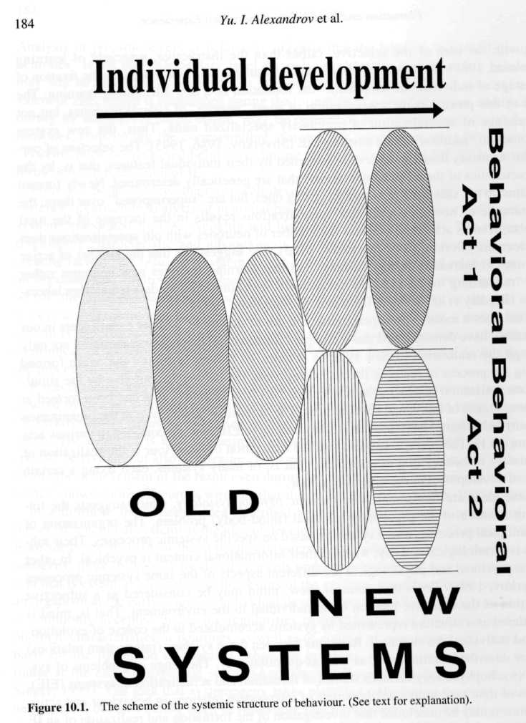
metabolic properties, and, during learning, only neurones with specific properties are incorporated into a system's organization. The stability of these properties was demonstrated in experiments with completely isolated nerve cells, by using the methods of mechanical and fermentative treatment.
When working with isolated neurones, cells keep the specific properties of background activity that they used to have in the nervous system. Alving (1968) used a mechanical method of isolation to demonstrate that the spontaneous electrical activity of isolated
Formation and Realization of Individual Experience 185
nerve cells which she recorded before isolation, stayed similar. Chen et al. (1971), using fermentative treatment, found that completely isolated identified neurones maintained, after isolation, the main electrophysiological characteristics, such as the level of membrane potential, rhythm and patterns of spontaneous and elicited activity. Chemosensitivity was also stable. Isolated neurones were characterized by chemo-sensitivity to the same neurotransmitters that were effective before isolation. Our experiments have been performed on completely isolated neurones of the snail Helix pomatia. The results confirmed the stability of individual electrophysiological characteristics of identified cells. Not only were the background activity and chemosensitivity found to be stable, but also the dynamics of complex forms of neuronal plasticity remained similar prior to and after isolation (Grechenko, 1993). So, from the comparison of these individual characteristics of the same cells in vitro and in vivo it can be concluded that the analyzed properties of neurones in adult animals are stable.
Culturing identified isolated neurones in vitro, and analyzing their properties after involvement in the formation of new neuronal networks, allows us to find out if these properties stay stable in such a new neuronal organization. Syed et al. (1990) have done the experiments by culturing neurones of Aplysia, which formed new interneuronal connections. During these experiments the authors tried to describe the modifications of the neuronal electrophysiological characteristics, but no modifications were elicited by the procedure of culturing or axonotomy, the main parameters of electrophysiological activity remaining constant. It is necessary to note that each neurone formed new synaptic connections similar to those functioning in vivo.
Similar results were obtained in two artificial neuronal nets: respiratory and motor networks. In the latter, the transformation of action potentials was explored in the course of associative learning. These modifications were similar to the experiments in vivo and in vitro. Individual properties of neurones were stable in the neurotransplantation experiments. The stability of structural, intrinsic neurotransmitter, and electrophysiological characteristics of graft transplanted neural tissue have also been shown (Vinogradova, 1994). These findings confirm the stability of individual properties of a neurone, and support views on the regularities of learning suggested by the system-selection concept.
3. RESULTS OF BEHAVIOUR AS A DETERMINANT OF FORMING OF INDIVIDUAL EXPERIENCE
Within the framework of our approach, the specialization of neurones is considered to be a systemic one instead of "sensory" or "motor". Thus, we assume that even in conditions of "sensory deprivation"—for example, cessation of contact with the visual environment—neuronal activity in "visual" structures is necessary for achievement of results of behaviour. Indeed, it was found that the activity of neurones in visual cortex, in retina and lateral geniculate body (Alexandrov and Aleksandrov; 1982; Alexandrov and Jarvilehto, 1993) is related to the realization of food-procuring behavioural acts in animals, both with "open" eyes and with eyes closed with light-tight covers. According to the same logic, it should be assumed that during the formation and realization of behaviour under "motor" deprivation, and even in combination of "sensory and motor" deprivation, the activity of neurones is related to the realization of systems aimed at achieving the
186 Yu. I. Alexandrov et al.
results of behaviour as well. This is shown by the fact that if an animal is restricted from moving voluntarily, but is nevertheless able to achieve some behavioural results during passive movement within an experimental arena, then a specific IE is formed, which corresponds to the analogous behaviour in freely moving animals. That is, neurones specialized according to the elements of this IE can be found.
This last assumption was tested in experiments (Gavrilov et al., 1994, 1996) with single unit recordings from CA1 complex-spike cells in awake rats, slightly restrained in a sling, and placed on a computer-driven robot. A rat was moved within a square arena (3 m x 3 m), from one corner to another, along the walls and diagonally. A drop of water was delivered (as a "reward") every time the rat approached one of the corners, this contingency remaining the same throughout the experiment. We found that about a half of the neurones increased their firing rate significantly while the rat was passively transported in particular parts of the arena, although these neurones had "spatial specificity" of low resolution, that is, their "firing fields" were larger compared to the those found in freely moving animals (O'Keefe and Nadel, 1979; O'Keefe and Recce, 1993). Some of these neurones maintained the same spatial selectivity of discharge when the rat was displaced on the robot in total darkness.
These results could be interpreted in terms of the currently-dominant views on the hippocampus as a pivotal structure for forming high-level representations of space on the basis of convergence of multimodal sensory information (O'Keefe and Nadel, 1979). From our point of view, these data support the idea of the determining role of results of behaviour in the formation of elements of IE. Representation of space is considered to be a reflection of the environment divided into elements according to the results achieved in this environment ("space of outcomes") on the base of some sensory "modalities". Formation of this representation is the formation of EIE. This also means that the existence of various spatially selective neurones which are active when the rat approaches one of the corners, irrespective of the direction and speed of passive displacements (i.e. irrespective of different means of attainment of the animal's contact with a particular place of the arena) is due to the fact that this place is in a constant spatial relation to that corner in which the animal was "rewarded" with water. Disappearance of the specific activation of hippocampal neurones when a restrained rat was placed into the "firing fields" of these neurones, that is, into the areas of the arena where these neurones had increased discharge activity when tested in freely moving rats (Foster et al., 1989), appears to be related to the change of behaviour from food-procuring to defense, and hence, to a change in the set of elements of the IE involved in the realization of the behaviour. Context-dependence of behaviour for spatial selectivity of discharges of the hippocampal neurons was shown earlier by Alexandrov et al. (1993) and Wiener et al., (1989).
In sum, the results described above offer good support for our assumptions. Even in restrained animals, passive transportation within the "space of outcomes" results in the activation of neurones in relation to the realization of EIE, which reflect the subjective "division" of the environment according to the results achieved in the environment. The result is similar to the findings for freely moving animals, although the structures of IE (both a set of elements and relationships between the elements) are probably different.
Formation and Realization of Individual Experience 187
4. LEARNING HISTORY AND SYSTEMIC ORGANIZATION OF BEHAVIOUR
From the assumption that the structure of IE is determined by the history of its formation, one may suppose that the systemic organization of the same behaviour, formed by different learning strategies, differs between individuals because the different history means the formation of a different IE structure. The role of learning history was demonstrated in our experiments. Rabbits were trained to perform a food-procuring instrumental behaviour in a cage with two feeders and two pedals in the corners (Figure 10.2). At any given moment, only one pedal was effective—pressing that pedal switched on a feeder positioned near the same wall. Two different strategies were used during the training of the animals. The animals of one group were trained to execute the whole behavioural cycle along one wall of the cage (pressing the pedal, coming to the feeder and seizing food, pressing the pedal, and so on), then along the other wall. The animals of the second group were trained to obtain food from one feeder, and then from the other; to press one pedal, and then to press the other one (Gorkin and Shevchenko, 1991a,b, 1995).
The reflection of the learning history in patterns of specialized neurones' activity was studied in experiments by recording the activity of limbic cortex neurones (area retro-splenialis) in rabbits. The averaged frequency of activity and the activation probability were calculated for each behavioural act. Each of two behavioural cycles (along a concrete wall of the experimental cage) was divided into five stages (behavioural acts): seizing food in a feeder, turning a head to a pedal, approaching a pedal, pressing a pedal, approaching a feeder. So, all food-procuring behaviour in the cage turned out to be presented in ten stages: 1st to 5th on the left side of the cage and 6th to 10th on the right side. For each stage we have defined the mean frequency of neuronal activity during the time of its recording, and the distribution of frequencies composed a pattern of neuronal activity in behaviour (Figure 10.2).
For further analysis we selected neurones specialized for new systems of acts of approaching and/or pressing pedals ("pedal" neurones), as well as acts of approaching and/or seizing food in one of the feeders ("feeders" neurones). Neurones that showed activation in relation to different movements of the animal were considered to be specialized relative to old systems. Whether their activation appears or not is related specifically to a certain movement but independent of its behavioral context. Activations always appear during the same movement, which is performed for instance in relation to approaching the feeder or the pedal. Some neurones showed activation in relation to novel behavioural acts established late in individual development, such as during animal's learning in the experimental cage (e.g. approaching the feeder, approaching the pedal, pressing the pedal). Whether their activation appears or not is specifically related to a certain behavioural act but independent of its motor characteristics. For example, similar activity of these neurones is recorded when the animal presses the pedal with the left paw, right paw, or both. It appeared during the behavioural act, for which this neurone was specialized. This activation was usually several times greater than the "nonspecific" activity of the neurone, which was recorded during other behavioural acts and which, unlike the specific one, was much more variable and appeared in fewer than 100% of cases.
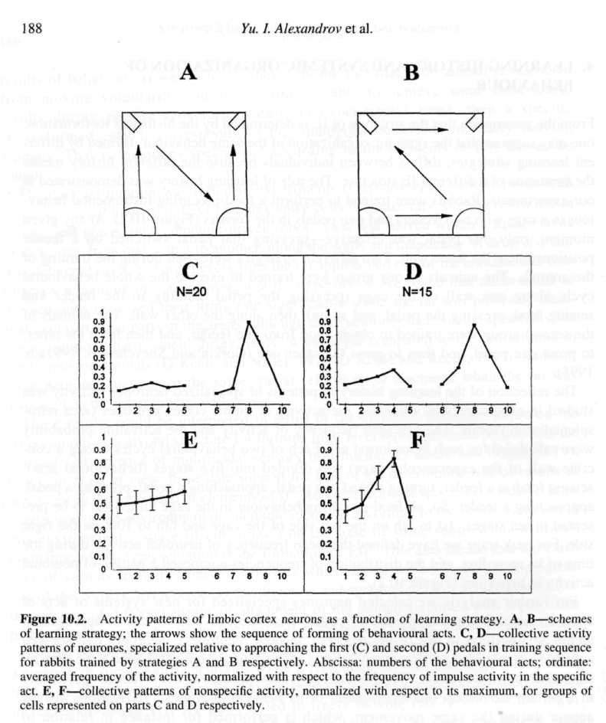
Comparison of the activity patterns of neurones with similar specialization showed that their "nonspecific" activity differed greatly (Figure 10.2 C,D). However, the distribution of frequencies was not random. There was additional activation of the neurones, specialized relative to the second pedal (with respect to the order of training), when the rabbit pressed the first one. Supplementary analysis involved normalization of the frequency of nonspecific activity with respect to the maximal frequency of activity during nonspecific acts (Figure 10.2 E,F). The analysis allowed this activation to be related to definite strategies of training. It appeared only when the formation of corresponding acts, related to the first pedal, directly preceded the formation of the acts of approaching and pressing the second pedal in the history of training. Thus, among the systems of behav-
Formation and Realization of Individual Experience 189
ioural acts formed during training one after another, and performed by an animal at different sides of the cage, we found facilitating intersystem relations manifested in a raised degree of actualization of the last-formed system while an animal performed the previous one. Achievement of an act's result is ensured by realization of a specific EIE as well as others. Whereas the specific EIE are realized in the act in all cases, the probability and the degree of actualization of nonspecific ones are considerably lower.
A similar phenomenon was found for "feeder" neurones as well. Additional activation was detected in the nonspecific activity of cells, specialized relative to the second feeder, in respect to the order of training. The particular place where this activation appeared— during approaching and pressing a pedal at the other side of the cage, or during seizing of food from the other feeder—depended on the strategy of training, that is, which act preceded the one specific for this neurone in the animal's training.
Earlier we showed that systemic specialization of a neurone is its permanent characteristic (Gorkin and Shevchenko, 1991a,b). That is why neuronal activity can serve as an index of specific EIE actualization (Shvyrkov, 1995), and "nonspecific" activity of a neurone may indicate the retrieval of a specific system from memory during performance of other behavioural acts. Studies of the activity of system-specific neurones during the performance of cyclic food-procuring behaviour may reveal the relations between the specific system and other functional systems of analyzed behaviour. Thus, identification of intersystem relations can reveal the IE structure acquired by learning. The data obtained confirm the assumption that the IE structure and, consequently, the system organization of behaviour in which this IE is actualized, are determined by the developmental history of the behaviour.
5. "PROJECTION" OF INDIVIDUAL EXPERIENCE UPON BRAIN STRUCTURES AND THE POSSIBILITIES OF ITS MODIFICATION
Spinelli (1978) obtained impressive data, which demonstrated that when kittens were trained to move their front paw in response to stimuli in one orientation, the area of representation of this paw in somatosensory cortex was significantly increased compared to the control animals. Later it was demonstrated that the steady reorganization of receptive fields corresponding to the characteristics of detected objects was induced by learning in adults as well (Tanaka, 1993). An analysis of the literature leads to the conclusion that receptive fields and cortical maps may be modified "at all times between conception and death" (Wall, 1988, p. 549), although the magnitude of these modifications may differ. For example, it was shown that cortical representation of the fingers of the left hand in string players was increased as compared to control subjects, and the increase was greater, the earlier a subject started learning to play (Elbert et ai, 1995). Traumatic influences, such as finger-amputation, that force animals to reorganize their behaviour, also induced receptive fields modifications and corresponding changes in cortical maps (reviewed by Wall, 1988).
Analysis of results of our many experiments brought us to the conclusion that testing of receptive fields of neurones reveals their involvement in subserving different behavioural acts (Alexandrov, 1989; Alexandrov and Jarvilehto, 1993; Shvyrkov, 1990). Taking this conclusion into account, it is possible to consider the results of these studies
190 Yu. I. Alexandrov et al.
as support for the postulate that the projection of IE upon brain structures in animals and humans changes in the course of individual development, and depends on its characteristics.
The study of the projection of IE upon brain structures in the present framework implies the comparison of patterns of systemic specialization of neurones belonging to these structures at different stages of individual development in normal and pathological subjects. A pattern of specialization of neurones (within the given structure) is defined according to the set of systems with respect to which units of this structure are specialized, and also according to the quantitative relation among neurones belonging to different systems. Comparison of patterns of specialization of neurones in rabbits' limbic and anterolateral motor cortex at successive stages of learning instrumental behaviour revealed that patterns were changed differently in the cortical areas studied (Gorkin, 1988; Shvyrkov, 1986). The change was due to the appearance of a new group of active neurones specifically related to the behavioural act after learning it (for example, pressing a pedal). The number of such new units in the limbic cortex was significantly greater than in the motor one. Thus the resulting specialization pattern of neurones in these structures was entirely different (Figure 10.3, Control): the limbic cortex, as well as hippo-campal CA1 and DG, acquired significantly more neurones with new specializations than did the motor cortex. Recording of unit activity in many cerebral structures during instrumental food-procuring behaviour, carried out in our laboratory, demonstrated that, generally, neurones with new specializations were abundant in the cerebral cortex (though different cortical areas may vary with respect to this parameter), whereas phylo-genetically archaic and peripheral structures had very few of them, if any (see Alexandrov, 1989; Shvyrkov, 1995). It is reasonable to assume that the specificity of IE projection to cerebral structures is determined by the particular characteristics of neurones composing these structures. These characteristics determine the involvement of neurones of the given structure in the formation of the particular behaviour.
Can anything besides normal learning cause change in IE projection? We found that after recovery of instrumental food-procuring behaviour in rabbits that had been impaired due to bilateral damage of visual cortex, the pattern of neurones' specialization in motor cortex was changed. The percentage of neurones specialized with respect to new systems increased (Alexandrov et al., 1990). Conversely, after acute ethanol administration the portion of active "new" neurones decreased, not however in the motor cortex (Alexandrov et al., 1991) but in limbic structures (Figure 10.3, compare Control and Ethanol) (Alexandrov et al., 1990a, 1993). This effect is due to selective suppression of the activity of neurones belonging to new systems, especially cells located in the upper cortical layers (II-IV). The similar increased sensitivity of relatively new EIE was also found at early ontogenetic stages—in altricial nestlings at the stage of formation of natural behaviour (Alexandrov and Alexandrov, 1993).
In order to test the hypothesis that the age of EIE, actualized during realization of behaviour, is one of the major factors determining the effects of ethanol in humans, we compared the impact of ethanol on event-related potentials (ERP) accompanying actions requiring the use of knowledge that subjects had acquired at earlier and later stages of individual development: at the time of acquisition of native and foreign languages, respectively. After alcohol intake, the amplitude of ERP components decreased, compared to the control condition, in the task of categorization of words of both native and
Formation and Realization of Individual Experience 191
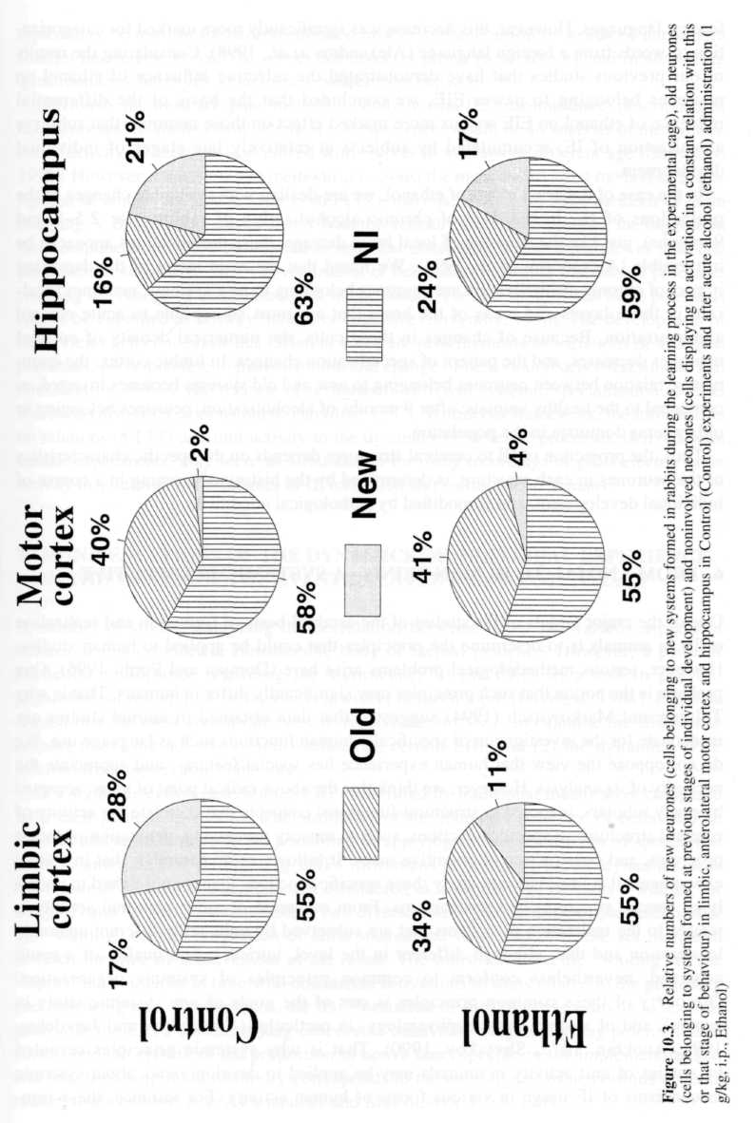
192 Yu. I. Alexandrov et al.
foreign languages. However, this decrease was significantly more marked for categorization of words from a foreign language (Alexandrov et al., 1998). Considering the results of our previous studies that have demonstrated the selective influence of ethanol on neurones belonging to newer EIE, we concluded that the basis of the differential influence of ethanol on EIE was its more marked effect on those neurones that subserve actualization of IE, accumulated by subjects at relatively late stages of individual development.
In the case of the acute effect of ethanol, we are dealing with reversible changes of the projections of IE. In the case of chronic alcoholization of rabbits (for 2.5-3 and 9 months), just like the situation of local brain damage, these modifications appear to be irreversible (Alexandrov et al, 1994). We found that the main target of the damaging impact of chronic alcoholization are neurones belonging to new systems; neurones localized in those layers and areas of the brain that are most susceptible to acute ethanol administration. Because of changes in these cells, the numerical density of cortical neurones decreases, and the pattern of specialization changes. In limbic cortex, the quantitative relation between neurones belonging to new and old systems becomes inverted, as compared to the healthy animals: after 9 months of alcoholization, neurones belonging to old systems dominate in the population.
Thus, the projection of IE to cerebral structures depends on the specific characteristics of the neurones in each structure, is determined by the history of learning in a course of individual development, and is modified by pathological conditions.
6. FROM ANIMAL TO HUMAN BEING—A SYSTEMIC PERSPECTIVE
One of the major targets of the studies of the cerebral basis of formation and realization of IE in animals is to determine the principles that could be applied to human studies. However, serious methodological problems arise here (Domjan and Purdi, 1995). One problem is the notion that such principles may significantly differ in humans. That is why Tulving and Markowitsch (1994) suggested that data obtained in animal studies are inadequate for the investigation of specifically human functions such as language use. We do not oppose the view that human experience has special features, and appreciate the necessity of its analysis. However, we think that the above radical point of view, accepted by many scholars, is rooted in structural-functional concepts that correlate the activity of cerebral structures to specific functions, such as sensory processing, generation of motor programs, and construction of cognitive maps. It follows, quite naturally, that in animal experiments it is impossible to study those specific functions that are not linked to underlying special structures and mechanisms. From our point of view, neuronal activity is related to the realization of systems that are subserved by units with different anatomic localization and that, although different in the level, intricacy, and quality of a result achieved, nevertheless conform to common principles of systemic organization. Discovery of these common principles is one of the goals of any systemic study in general, and of systemic psychophysiology, in particular (Alexandrov and Jarvilehto, 1993; Anokhin, 1973; Shvyrkov, 1990). That is why systemic principles revealed by studies of unit activity in animals may be applied to develop views about systemic mechanisms of IE usage in various forms of human activity. For instance, these prin-
Formation and Realization of Individual Experience 193
ciples may be used in the aforementioned task of categorization of words of native and foreign languages, as well as in operator tasks, in group game activity and in answering questionnaires for psychodiagnostic research (see below).
Obviously the most adequate method to study human IE, enabling direct description of taxonomy and relations among elements of experience, would be an analysis of the dynamics of activity in neurones specialized with respect to systems of different age (Shvyrkov, 1995). However, for ethical and methodical reasons, the most widely used method of investigation of human cerebral activity is still EEG-analysis, along with other methods of brain mapping. V.B. Shvyrkov substantiated, both theoretically and experimentally, the suggestion that components of ERPs correspond to neuronal discharges, and to dynamics of systemic processes, at successive stages of realization of behaviour, including transitional processes ensuring the change of behavioural acts in continuum. He also showed that brain potentials cannot be classified as sensory, motor, or cognitive (Shvyrkov, 1990). The development of these views helped to show that different ERPs are just fragments or variations of averaged potentials, corresponding to the realization and change of behavioural acts (Maksimova and Aleksandrov, 1987). The relation of neurones of different systemic specialization to EEG waves has also been demonstrated (Gavrilov, 1987). Within our framework, the information on relations of EEG and unit activity to the dynamics of systemic processes, derived from animal experiments, may serve as a foundation for using recordings of gross electric brain activity in studies of the principles of IE formation and realization in humans.
7. MANIFESTATIONS OF THE DYNAMICS OF INDIVIDUAL EXPERIENCE IN THE WAVEFORM OF EVENT-RELATED BRAIN POTENTIALS
A number of studies analyzing the correlation between ERPs and various aspects of behaviour has provided a considerable body of factual evidence. However, a point of particular importance regarding the significance of the ERPs as a tool in psycho-physiological research of behaviour is a widely debated topic (Loveless, 1984). It can be argued that the most appropriate way to resolve the matter is to examine the ERPs with respect to (1) the activity of units related to certain EIE, and (2) the dynamics of IE inferred from observable behaviour.
In a signal detection task, human ERPs identified by traditional means were compared with their analogs in rabbits. The similarity of the temporal structure of behaviour in humans and animals gave us the possibility of applying data on the activity of specialized cortical units, and of interpreting ERPs in humans in terms of the IE dynamics. The behaviour of humans and animals was considered as a sequence of two acts ("waiting for a signal" and "report"), maintained by two diverse sets of EIE. During implementation of the "waiting" act the proportion of units specialized with respect to the act increased towards the time of achievement of the result. The transition from the "waiting" to the "report" act coincides in time with concurrent activations of units related to the preceding and following acts. Furthermore, the transformation of sets of active units is in accordance with the ERPs accompanying observable behaviour: Negative-going potential shift corresponds to growth of the proportion of active units specific to the implementing act, whereas high amplitude positivity corresponds to the overlapping of activations of units related to successive acts (Aleksandrov and Maksimova, 1985, 1987).
194 Yu. I. Alexandrov et al.
Our review of the ERPs suggests that the slow negative wave, and following high amplitude positivity, are the basic components of a unified potential. The unified potential accompanied the subject's behaviour in different experimental paradigms, including the behaviour of various species (Maksimova and Aleksandrov, 1987). It is important to note that these components may be conventionally labeled as the CNV-P300 complex, or the readiness potential-motor potential complex, etc. Thus, if the subject performs a task as a succession of two behavioural acts, then a unified biphasic potential waveform will be recorded. Therefore, one could state that the unified ERPs' waveform manifests successive stages of transformation of EIE sets underlying ongoing behaviour. Negative components represent outward growth of the set's consistency, and positive components represent decrease of the set consistency. According to this view, the use of ERPs in the psychophysiological study of behaviour can be extended to human voluntary activity. Clearly, a formal description of overt behaviour as well as of IE dynamics is needed to achieve this.
Within this framework, overt behaviour and the correlation of IE dynamics with ERPs, were analyzed for subjects engaged in a strategic game, with full information and zero sum of two players. Tic-tac-toe, on a 15 x 15 gameboard, was employed as an experimental paradigm (Aleksandrov, 1995; Aleksandrov and Maksimova, 1988; Maksimova, 1995). The subject's play in the game was defined as the relation between two successive moves of his opponent. The formal description of the play included numerical indices of three successive situations on the gameboard: (1) before and (2) after, the player's move, and (3) after the return move of the opponent. Plays with identical numerical indices were assigned to the same type. The protocol of the game described as the serial moves of two players was transformed into two protocols of individual plays. Stable sequences of 2-7 plays were considered as strategies. Protocols of individual plays served as a basis for formal description of the player's IE structure, components of which represented the relation between the plays and strategies.
To select the best description of the structure and dynamics of IE, different multiple regression models of the serial plays were compared. The results of the modelling were as follows. After the player's move, alternative IE sets represented all the likely plays after the opponent's anticipated moves are actualized. The player's move rejects IE sets that contradict an actual situation. At that moment IE sets, other than rejected ones, are actualized and influence decision-making, but are never observed in overt behaviour.
Occurrence of play corresponds closely to ERPs of a unified waveform. Slow negative shifts coincide with sequential plays, and positive waves of high amplitude persists until the opponent's return move. Slow negativity correlates with the transformation of EIE, set initially for the choice of move, that is, the rejection of alternative plays. Fragments of the negative wave reflect consecutive stages of the selection of the EIE specific to an actual move. In contrast, the high amplitude positive potential reflects the actualization of the EIE sets.
To estimate the extent to which amplitudes of ERPs are determined by the dynamics of EIE, a backward stepwise multiple regression procedure was applied. Maximum amplitudes of raw negative and positive potentials recorded in players were used as the dependent variables. Parameters of EIE (the number of components representing the plays, strategies, the entropy of components' sets, and indices of their interrelations) at corresponding intervals, were used as independent variables. Simulation revealed that nearly
Fonnation and Realization of Individual Experience 195
40% of the variance of the ERPs' amplitudes can be explained by the EIE dynamics (Aleksandrov and Maksimova, 1996). The analysis can be considered to be valid, taking into account the possibility that a significant part of the variance of the ERPs amplitude is related to postural control, and vascular and metabolic aspects of the neural tissue activity.
The remarkable aspect of the data was that players master the game while they continue to play (Aleksandrov, 1995; Maksimova, 1995). The total number of acquired IE components is fitted well by a power function of the number of moves performed. In the main, the results implied that the rate of acquisition of new IE components can be assessed by the exponent of a power function. For plays and strategies it is less than 1; for interrelations it is significantly greater than 1. It is our view that ERPs may serve as indicators of the course of forming and realization of new IEs (the EIE dynamics).
8. DYNAMICS OF ERP CHARACTERISTICS AND INTERSYSTEM RELATIONS DURING SKILL DEVELOPMENT
With repeated performance of behavioural acts, subjects improve their performance (Adams, 1987), that is, they achieve the ability "to bring about some end result with maximum certainty and minimum outlay of energy, or of time and energy" (Guthrie, 1952, p. 136). The transformation of ERPs' components that accompany the stages of mastering the behaviour (Hansen and Hillyard, 1988) can be considered to be an indicator of the changes of relations among EIE that underpin this behaviour. Hence, the dynamics of the ERPs over the course of mastering a behaviour allows us to investigate modifications of intersystem relations.
In our study subjects were employed in a choice reaction time task which demands prolonged training and, therefore, allowed us to investigate changes in ERPs at successive stages of the task.
In the first series of experiments subjects were presented with equiprobable alternative visual signals in a random sequence. Their task was to release a home button and press a report button corresponding to the presented signal as quickly as possible.
One could recognize at least two steps by which ERPs changed. At first, these changes appeared both in frontal and parietal ERPs, corresponding only to quick and correct reports of a target signal, whereas these changes were only in frontal but not in parietal ERPs corresponding to reports of other signals. At the next stage, the frontal ERPs maintained their changed shape during further training; report time became shorter; the number of erroneous reports decreased; and the shape of parietal ERPs became similar to that of frontal ERPs (Bezdenezhnych, 1993). We proposed that these changes, reflecting improvement in the subject's performance, are related to the changes in well known sequential effects.
The second series was based on the assumption that each current report in this task was influenced by the preceding ones, and these sequential effects were reflected in ERPs and, particularly, in P300. The subject had to release the home button and press the button corresponding to one stimulus after its onset (Quick-go), and the button corresponding to another stimulus after its offset (after 900 ms, Delay-go) as quickly as possible. The ERPs related to these reports were distinguished by their P300: In par-
196 Yu. I. Alexandrov et al.
ticular, the mean amplitude and peak latency of P300 corresponding to Delay-go reports were significantly greater than those of P300 corresponding to Quick-go.
Initially both amplitude and latency of P300 changed. In all subjects the P300 amplitude increased when it was related to the report preceded by Delay-go report, and it decreased when it was related to the report preceded by Quick-go report. In four subjects P300 latency decreased, and in two subjects it increased when the preceding report was an alternative to the present one. At a second stage of the experiment the mean report time became significantly shorter, and erroneous reports disappeared. The P300 latency became independent of the preceding report. The P300 amplitude continued to depend on the preceding report. At a third stage of the experiment, report time became more stable, and there were no sequential effects on either the amplitude or latency of P300.
Taking into account the suggestion that P300 amplitude reflects a readout from memory of EIE related to a current act (Aleksandrov and Maksimova, 1985; Maksimova and Aleksandrov, 1987), one can draw the following conclusions: In the course of mastering the tasks, the number of EIE actualized in a current report are reduced at the cost of an "inhibition" of an active EIE corresponding to the preceding response. Mastery is also accompanied by fixing the timing of EIE realizations to the act of reporting. It is possible that the changes in parietal ERPs reflect the processes which belong to the later stages of learning, whereas processes reflected by frontal ERPs belong to the earlier ones. Inasmuch as the representations of new EIE prevail in the structures whose activities are reflected in frontal derivations (Bezdenezhnych, 1993), one can propose that the relations among these EIE determine learning.
9. STRUCTURE OF INDIVIDUAL EXPERIENCE IN DIAGNOSTICS OF PERSONALITY
In the framework of the suggestions presented above, some light can be shed on key aspects of the problem of description and diagnostics of generalized characteristics of individuality. According to generally accepted notions, an individual peculiarity of a person can be considered as a generalized characteristic only at a certain (high) level of constancy, in which it is possible to differentiate two interrelated facets: stability and consistency (Mischel and Shoda, 1995).
The first aspect refers to the temporal constancy of demonstrated characteristics of individuality. The higher the temporal stability of the individual peculiarity, the higher the probability that the given characteristic belongs to the class of essential features of the individual. Under a high level of temporal stability, individual specificity reflects the most stable components of the IE structure, as well as the most strong relations among them.
The second (more important) facet, consistency, is related to the specificity of an individual characteristic in different instances of interaction with environment, that is, in different behavioural acts relevant to this individual characteristic. A high level of consistency of an individual peculiarity reflects the specific organization of generalized experience for coping with the environment. This experience is formed in ontogenesis on the basis of inborn dispositions (Bodunov, 1988). The higher the consistency of an individual, the higher its stability (temporal constancy). The higher level of consistency
Formation and Realization of Individual Experience 197
testifies to the stronger expression of an individual trait. The emergent nature of their genetic determination has been demonstrated for many consistent individual characteristics (Lykken and McGue, 1992).
Widespread methods of diagnosing individual characteristics by means of questionnaires evaluate the consistency of individual characteristics, through items representing typical situations in which the characteristic can be manifest. The primary factor, which mediates the subject's response-selection in personality questionnaires, is the structure of the IE as a whole.
One experimental method for modifying the structure of an actualized IE, is acute alcohol consumption, which, as we showed, suppresses the activity of new EIE (see above). This characteristic of alcohol allowed us to use it as a methodological means of selective inhibitory influences of EIE, which determine the manifestation of consistent individual characteristics.
Computerized versions of the Pavlovian Temperamental Survey, the NEO Five-Factor Inventory and the Structure of Temperament Questionnaire were administered to a sample of subjects. The experimental group of subjects consumed alcohol (1 ml/kg) before performing the test battery. The control group of subjects completed the tests after receiving equivalent amount of nonalcoholic liquid. We found that alcohol does not change the mean values of scales related to generalized characteristics of individuality. The structure of relations among characteristics did not change significantly. However, change in the mean value of one of the characteristics ("Conscientiousness" from the NEO Five-Factors Inventory) can be explained by the supposition that new EIE are reflected in this characteristic to a greater degree. Under the influence of alcohol, changes in the proportion of preferred variants of responses (matrices of responses) for some test items were detected. It was assumed that in this type of item, new IE was actualized to the greatest extent. For a large number of test items of multivariant type, reduction of the latent periods of responses was observed with alcohol. We assume that inhibition of intersystem relations (formed between EIE, which are associated with different variants of responses) plays a leading role in this reduction.
Test items were selected by the authors from personality and temperament questionnaires, on the basis of hypothetical (mainly intuitive) beliefs about the manifestation of individual characteristics in different behavioural situations. In the framework of our approach, the role of EIE of different stages is manifest in the different responses to test items on the personality questionnaires. Thus, not only can we identify features of the structure of IE that mediate individual differences revealed by these questionnaires, but we can also design new methods of generating test items which relate to the EIE formed at different stages of individual development.
10. CONCLUSIONS
The framework of systemic psychophysiology has been described. Data were described from studies of unit activity in vitro, and in awake normal and pathological animals learning new behaviours, and realizing previously-learned behaviours (both complex instrumental behavior and simple acts). Data were also described from experiments with human subjects who learned and performed tasks of word categorization and skilled per-
198 Yu. I. Alexandrov et al.
formance, and board games, and who answered psychodiagnostic questionnaires. Based on these descriptions, qualitative and quantitative descriptions of the principles of formation and realization of individual experience were suggested in the framework of a unified methodology. From the authors' point of view, the development of a new system—systemogeny—is considered to be the fixation of a stage of individual development. The performance of a behaviour is the simultaneous realization of many elements of individual experience, formed at different stages of individual development. The dynamics of formation and actualization of the structure of individual experience were thus demonstrated, and the relations among elements of individual experience in different forms of behaviour and at different stages of its formation and realization were described.
ACKNOWLEDGMENTS
The authors wish to express their appreciation to L.I. Alexandrov and O.E. Svarnik for their assistance with preparation of the manuscript. The studies described above were supported by grants provided by the Russian Humanitarian Scientific Fond (NN 99-06-00169, 95-06-17292, 96-03-04627), the Russian Fund for Fundamental Research (NN 93-06-10787, 96-06-80626, 96-15-98641, 97-06-80275), the Finnish Academy of Sciences, The Finnish Foundation for Alcohol Studies, the Foundation pour la Recherche Medicale, Human Frontiers, CNRS Programme Cognisciences.
REFERENCES
Adams. J.A. (1987) Historical review and appraisal of research on the learning, retention, and transfer
of human motor skills. Psychological Bulletin. 101. 41-174.
Aleksandrov. I.O. (1995) Assessment of the acquisition rate of procedural and declarative components of
individual knowledge. European Journal of Psychological Assessment. 11. Supplement. 66. Aleksandrov. I.O. and Maksimova. N.E. (1985) P300 and psychophysiological analysis of the structure
of behavior. Electroencephalography Clinical Neurophysiology, 61. 548-558.
Aleksandrov, ! Э. and Maksimova. N.E. (1987) Slow brain potentials and their relation to the structure
of behavior- Data on cortical unit activity. In: R. Johnson. J.W. Rohrbaugh. and R. Parasuraman
(eds.). Current Trends in Event-Related Potential Research (EEG Suppl. 40) pp. 4-7 Amsterdam:
Elsevier.
Aleksandrov. I.O. and Maksimova, N.E. (1988) P300 and validity of psychopysiological description of
behavior. Behavioral and Brain Sciences, 11. 374.
Aleksandrov. I.O. and Maksimova. N.E. (1996) Modeling of EEG amplitude in humans using parameters of the
individual knowledge structure. In: 8th World Congress of IOР. June 25-30. Tampere. Finland. Alexandrov. L.I. and Alexandrov, Yu.I. (1993) Changes of auditory evoked potentials in response to behav-
iorally meaningful tones induced by acute ethanol intake in altricial nestlings at the stage of formation of
natural behavior. Alcohol. 10. 213-217.
Alexandrov. Yu.I. (1989) Psychophysiological significance of activity of central and peripheral neurons in
behavior. (In Russian) Moscow: Nauka.
Alexandrov Yu.I. and Aleksandrov. I.O. (1982) Specificity of visual and motor cortex neurons activity in
behavior. Acta Neurobiologiae E.xperimentalis. 42. 457—468.
Alexandrov. Yu.I.. Grinchenko, Yu.V. and Jarvilehto. T. (1990) Change in the pattern of behavioral specialization of neurons in the motor cortex of the rabbit following lesion of the visual cortex. Acta Physiologica
Scandinavica.. 139. 371-385.
Alexandrov. Yu.I.. Grinchenko. Yu.V.. Laukka S.. Jarvilehto Т., Maz V. and Svetlaev, I. (1990a) Acute effect
of ethanol on the pattern of behavioral specialization of neurons in the limbic cortex of the freely moving
rabbit. Acta Physiologica Scandinavica. 140. 257-268.
Formation and Realization of Individual Experience 199
Alexandrov. Yu.I. Grinchenko. Yu.V.. Laukka. S.. Jarvilehto, T. and Maz V. (1991) Acute effects of alcohol on
unit activity in the motor cortex of freely moving rabbits: Comparison with the limbic cortex. Acta
Physiologica Scandinavica, 142. 429-435.
Alexandrov, Yu.I., Grinchenko, Yu.V.. Laukka. S., Jarvilehto, Т., Maz V. and Korpusova A. (1993) Effect of
ethanol on hippocampal neurons depends on their behavioral specialization. Acta Physiologica
Scandinavica. 149. 105-115.
Alexandrov, Yu.I. and Jarvilehto, T. (1993) Activity versus reactivity in psychology and neurophysiology.
Ecological Psychology. 5, 85-103.
Alexandrov, Yu.I.. Korpusova, A.V., Grinchenko. Yu.V, Jarvilehto. T. and Laukka S. (1994) Structural changes
and reorganization of cortical neurons' activity in behavior of chronically alcoholized rabbits. Zhurnal
Vysshey Nervnoy Dejatelnosty, 44, 1077-1085 (in Russian).
Alexandrov, Yu.I., Sams, M., Lavikainen. Yu.. Reinikainen. K. and Naatanen R. (1998) Differential effects of
alcohol on the cortical processing of foreign and native language. International Journal of
Psychophysiology, 28. 1-10.
Alving. B.O. (1968) Spontaneous activity in isolated somata of Aplysia pacemaker neurones. Journal of
General Physiology, 51. 29-45.
Anokhin. K.V. and Rose. S.P.R. (1991) Learning-induced increase of immediate early gene messenger RNA in
the chick forebrain. European Journal of Neuroscience. 3. 162-167.
Anokhin. P.K. (1973) Biology and neurophysiology of conditioned reflex and its role in adaptive behavior.
Oxford: Pergamon Press.
Bezdenezhnych. B.N. (1993) Dynamics of EEG potentials during attention tasks. Psychologichesky Zhumal.
14. 120-130 (in Russian).
Bodunov, M.V. (1988) Individual rate as a generalized formally-dynamic characteristic of behavior.
Psychologichesky Zhumal. 9, 33-43 (in Russian).
Bottjer. S.W.. Braun. K.. Cline. H.. Dudai. Y.. Fernald. R.D.. and Hammer. L. et al. (1994) Group report: to
what extent does experience reorganize the brain and behavior? In: R.J. Greenspan and C.P. Kyriacou
(eds.) Flexibility and constraint in behavioral systems. Chiehester, Wiley, pp. 133-146.
Bradley. P.M.. Burns. B.D.. King. T.M.. and Webb. A.C. (1996) Electrophysiological correlates of prior training: An in vitro study of an area of the avian brain which is essential for early learning. Brain Research.
708. 100-107.
Bullier. J. and Nowak. G. (1995) Parallel versus serial processing: new vistas on the distributed organization of
the visual system. Current Opinion in Neurobiologx. 5. 497-503.
Chen. C.F., von Baumgarten. R.I. and Takeda. R. (1971) Pacemaker properties of completely isolated neurones
in Aplysia californica. Nature. London. 233. 27-29.
Domjan. M. and Purdy. J.E. (1995) Animal research in psychology. American Psychologist. 50. 496-505. Edelman. G.M. (1987) Neural Darwinism: The theory of neuronal group selection. New York: Basic.
Eimer. M.(I993) Effects of attention and stimulus probability on ERPs in a Go/No go task. Biological
Psychology. 35. 123-138.
Elbert. Т.. Pantev. C. Wienbruch. C. Rockstroh. B. and Taub. E. (1995) Increased cortical representation of the
lingers of the left hand in string players. Science. New York. 270. 305-307.
Foster. T.C.. Castro. C.A. and McNaughton. B.L. (1989) Spatial selectivity of rat hippocampal neurons:
dependence on preparedness for movement. Science. New York. 244. 1580-1582.
Gavrilov. V.V. (1987) Relation of EEG and unit activity in rabbits" behavior. In V.B. Shvyrkov, V.M. Rusalov,
and D.G. Shevchenko (eds.). EEG and Neuronal Activity in Psychophxsiological Experiments (in Russian)
pp. 33-44 Moscow. Nauka.
Gavrilov. V.V.. Wiener. S.I. and Berthoz. A. (1994) The properties of hippocampal neurons observed during
passive displacement of rats on a mobile robot. Journal of Neuroscience. Supplement 7. 137.
Gavrilov. V.V.. Wiener. S.I. and Berthoz. A. (1996) Discharge correlates of hippocampal neurons in rats
passively displaced on a mobile robot. Society for Neuroscience Abstracts. 910.
Gorkin, A.G. (1988) Learning and neuronal specialisation. In: V.B. Shvyrkov and R. Naatanen et al.. (eds.).
Psychophysiology of cognitive processe pp. 99-104 Moscow, Institute of Psychology. Academy of
Sciences.
Gorkin. A.G. and Shevchenko, D.G. (1991a.) The stability of units behavioral specialization. Neuroscience and
Behavioral Physiology. 21. 222-229.
Gorkin, A.G. and Shevchenko. D.G. (1991b) Structure of memory as a determinant of activity of the
system- specific neurons. Soviet Journal of Psychology. 12. 60-69.
Gorkin. A.G. and Shevchenko. D.G. (1995) Differences in activity of rabbits' limbic cortex neurons as
determined by learning strategy. Zhumal Vysshey Nervnoy Dejatelnosty. 45. 90-100 (in Russian). Grechenko. T.N. (1993) Active memory: neurophysiological researching. Journal of Russian and East
European Psychology. 31. 55-72.
Guthrie. H.R. (1952) The psychology of learning. New York: Harper.
200 Yu. I. Alexandrov et al.
Hansen, J.S. and Hillyard. S.A. (1988) Temporal dynamics of human auditory selective attention.
Psychopkysiology, 25. 316-329.
Loveless, N. (1984) Book review. Biological Psychology, 18. 77-79.
Lykken. D.T, McGue. M, Tellegen. A. and Bouchard. T.J. (1992) Emergenesis: Genetic traits that may not run
in families. American Psychologist. 47. 1565-1577.
Maksimova. N.E. and Aleksandrov, I.O. (1987) Typology of brain slow potentials, neuronal activity and
dynamics of system organization of behavior. In: V.B. Shvyrkov. V.M. Rusalov and D.G. Shevchenko
(eds.), EEG and Neuronal Activity in Psychophvsiological Experiments (in Russian). Moscow: Nauka.
pp. 44-72.
Maksimova. N.E. (1995) An experimental paradigm for quantitative estimation of the individual knowledge
acquisition. European Journal Psychological Assessment, 11. Suppl.
Mischel. W. and Shoda Y. (1995) A cognitive-affective system theory of personality: Reconceptualizing situations, dispositions, dynamics, and invariance in personality structure. Psychological Review. 102.
246-268.
Mountcastle, V.B. (1995) The evolution of ideas concerning the function of the neocortex. Cerebral Cortex. 5.
289-295.
O"Keefe, J. and Nadel, L (1979) The hippocampus as a cognitive map. Behavioral Brain Research. 2. 487-533. O'Keefe. J. and Recce. M.L. (1993) Phase relationship between hippocampal place units and the EEG theta
rhythm. Hippocampus. 3, 317-330.
Shyleinkina, K.V. and Khayutin, S.N. (1989) Modern systemogeny theory. Zhurnal Vysshey Nervnoy
Dejatelnosty, 49, 3-19 (in Russian).
Shvyrkov. V.B. (1978) Neuronal mechanisms of learning as a formation of a functional system of behavioral
act. In: Mechanisms of Systemic Cerebral Activity (In Russian). Gorky, Gorky Medical Institute.
pp. 147-149.
Shvyrkov, V.B. (1986) Behavioral specialization of neurons and the system-selection hypothesis of learning. In:
F. Klix, and H. Hagendorf (eds.) Human Memory and Cognitive Capabilities. Amsterdam: Elsevier.
pp. 599-611.
Shvyrkov, V.B. (1990) Neurophysiological study of systemic mechanisms of behavior. New Delhi: Oxonian
Press.
Shvyrkov. V.B. (1995) Introduction to objective psychology. In: Yu.I. Alexandrov (ed) Neuronal Basis of Mind
(in Russian) Moscow: Institut Psychology. Russian Academy of Sciences.
Singer. W. (1995) Development and plasticity of cortical processing architectures. Science, New York 270.
758-764.
Spinelli. D.N. (1978) Neural correlates of visual experience in single units of cats visual and somatosensory
cortex. In: Frontiers in Visual Science, New York: Springer, pp. 674-688.
Sudakov, K.V. (1979) Systemogeny of behavioral act. In: Mechanisms of Brain Activity (in Russian). Moscow,
Gosnauchtechizdat. pp. 88-89.
Syed. N.J.. Bulloch. A.G.M. and Lukowiak. K. (1990) In vitro reconstruction of the respiratory central pattern
generator of the mollusc Limnaea. Science, New York. 250. 282-285.
Tanaka. K. (1993) Neuronal mechanisms of object recognition. Science, New York, 262, 685-688.
Tulving. E. and Markowitsch. H.J. (1994) What do animal models of memory model? Behavioral and Brain
Sciences. 17. 498-499.
Vinogradova. O.S. (1994) Some factors controlling morpho-functional integration on the transplanted
embryonic brain tissue. Zhurnal Vysshey Nervnoy Dejatelnosty, 44, 414-430.
Wall. J.T. (1988) Variable organization in cortical maps of the skin as an indication of the lifelong adaptive
capacities of circuits in the mammalian brain. Trends in Neuroscience, 11, 549-561.
Wiener. S.I.. Paul. С A. and Eichenbaum H. (1989) Spatial and behavioral correlates of hippocampal neuronal
activity. Journal of Neuroscience, 9, 2737-2763.
Wilson. M.A. and McNaughton B.L. (1993) Dynamics of the hippocampal ensemble code for space. Science.
New York, 261, 1055-1058.

